Anomalous Counts from the APD Boards

Purpose: To quantify the discovery of anomalous counts from the APDs, in terms of frequency and amplitude.

Background: During the course of measuring the edge segment transmission profiles, it was discovered that counts were being recorded on segments that were not being illuminated. It was further noted that these segments were usually the ones numerically prior to the illuminated segment (i.e. if #23 is illuminated, #22 may show anomalous counts), and that these events happened sporadically with a large count value (typically 1023, and often a value of 2^n-1). These anomalous counts stop when the adjacent segment is no longer recording light.

Procedure: The procedure is the same for the edge segment profile. In this case, the data is from the experiment where the transmission profile for #33 was being measured, and after scanning past the inner edge of this segment, segment #16 then #5 were illuminated. Capture data from these two positions is used for this report.

Result: The table below shows which segments showed anomalous counts for each illuminated segment. The numbers shown in the “counts” column are values displayed on the screen, which are typically the mean of over 100 measurements and thus to do represent the actual values of the counts. These anomalous counts were seen in phase A only. While most segments were illuminated in this test, a few of the inner segments were not since the goal of the experiment was to map the transmission profile of the outer segments. When the segments are individually illuminated, 29% (9 of 31) show anomalous counts. The nature of these events is explored using the capture data mentioned above.
Capture data was taken when segments #5 and #16 were illuminated. When #5 was illuminated, the mean counts were ~23, with no counts above 40 or less than 10 over the span of 2,000 data points. During this same span, segment #6 (an non-illuminated segment) showed only 1 measurement above 1 count. However, segment #4 had 208 measurements above 2 counts during this span, and in fact all of these measured 127 counts. When #16 was illuminated, the mean counts were 14 with no measurement below 5 or above 30 over the span of 2,000 data points. During this span, segment #18 (an non-illuminated segment) showed 2 measurements above 1 count. Segment #17 had 83 measurements above 2 counts during this span. Unlike the case for segment #4, the counts varied from 1022 to 32759. It also appears that certain values were measured at random, for example 17270 counts were measured several times but without any clear pattern as to when it was measured.
According to the image headers, the membrane frequency is 1900Hz, and data is written to the fits file once per cycle. For the case of #4, 208 anomalous counts over the span of 2000 measurements corresponds to an anomalous count frequency of 197.6 Hz, and for #17 the anomalous count frequency is 78.8 Hz.
The source of these anomalous counts is believed to be in the counter boards. Each segment appears to behave normally when there is no light on the lenslett array, as well as then that individual segment is illuminated with the laser. These counts do not appear to be related to the edges of the lenslett segments scattering light, since these counts do not seem to depend upon where the beam is in the illuminated segment or the intensity of the light. Also, the channel with anomalous counts records 0 or 1 counts at all times unless there is a high count, i.e. there is not a steady rise or descent from the high count. Furthermore, these counter boards have since been replaced, and no segment currently shows this anomalous behavior.

Conclusion
Anomalous counts of high amplitude and frequency were observed when the segment was not being illuminated but its neighbor was. This occurred in nearly 30% of segments, with counts ranging from just over 100 to over 30,000. In the two cases where capture data is available, the anomalous count frequency was 79 Hz and 198 Hz. Since all segments otherwise record counts normally (including those showing anomalous counts when they are illuminated), we believe the source lies in the counter boards rather than the APDs.

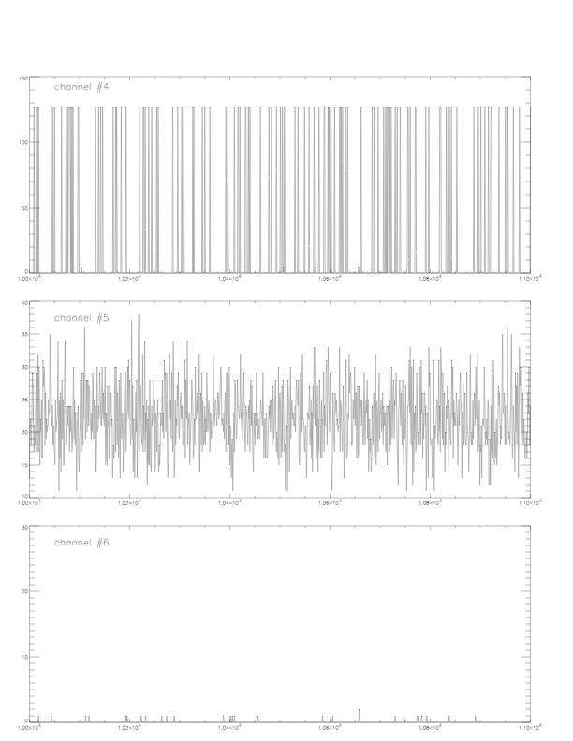
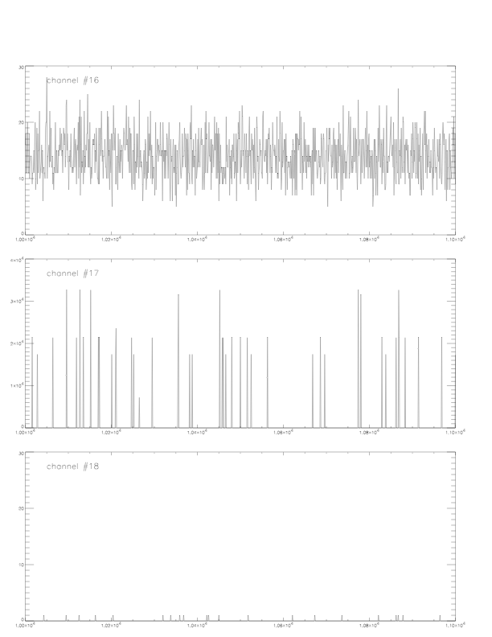
Segment w/ Illuminated
Anomalous counts Segment Counts
 | 0
0 | 1 | 1023, 767
none | 2
5 | 4 | 111, 255
4 | 5 | 255, 127
 | 6
 | 7
none | 8
8 | 9 | 1023, 3767
none | 10
10 | 11 | 1023, 127
 | 12
12 | 13 | 255, 1023
none | 14
 | 15
17 | 16 | 21336, 21984
none | 17
none | 18
18 | 19 | 32767
none | 20
none | 21
none | 22
22 | 23 | 1023
none | 24
none | 25
none | 26
none | 27
none | 28
none | 29
none | 30
none | 31
none | 32
none | 33
none | 34
none | 35

