1. Summary of LittleDog controlled devices

This table summarizes the devices controlled by the littledog computer.

The SPeX mechanisms can be grouped into 4 types: detented wheels, continuous rotary, continuous linear, and 2-position linear.

The detented mechanisms are the Dichroic Turret, Order Sorter Filter, Slit Wheel and Guider Filter Wheel. Each of these mechanisms is effectively a wheel with discrete positions provided by a detent notch machined on the wheel. The wheel is locked into place when positioned in the detent. An HESensor indicates when the wheel is positioned in the detent by sensing the presence of a magnet located at each detent. The HESensor can also sense a single Home magnet positioned between 2 of the wheel’s detents. The PC58 Controller/Stepper motor drives these mechanisms. A PC58 input bit is tripped ON when the sensor is in a detent. The PC58 axis home bit is tripped ON when the sensor is near the Home magnet. The output of the HESensor is also connected to an AD16 A/D channel.

The continuous rotary wheels are the Rotator and Grating Turret. These wheels have a single magnet and HESensor. The output of the sensor is connected to the AD16 A/D channel. These are high resolution anti-backlash mechanisms. They use a complex home algorithm to precisely calculate their home positions.

A continuous linear mechanism is used for the Array Focus Stage. This stage has a duel magnet / HESensor setup which can encode the position of the stage. The sensor is connected to an AD16 A/D input. The center position of the stage is located at 0 volts. As the stage moves in the negative direction, the voltage becomes more negative. As the stage moves in the positive direction, the voltage becomes more positive.

The 2-position linear mechanism is used for the calibration mirror.

There are calibration lamps that are controlled by turning off or on their power supplies.

Two temperature controllers are connected to littledog though its serial port. You can communicate directly with these controllers using the SPeX software or the tc330_tool application.

2. Calibration Mirror & Lamps

2.1 Summary of Cal_Mirror & Lamps

A stepper motor drives a linear stage to position the calibration mirror In or Out of the beam. A Baytech RPC3 (Remote Power Control) switch controls the A/C power to 4 power supplies to turn the 4 SpeX calibration lamps, and shutter On and OFF. The following diagram illustrates the interface to the PC-58 motor controller, the RPC3, and provides some motor position information.

See section 10 for description of RPC-3 unit use to control the calibration lamp power.

3. The Dichroic Wheel

3.1 Summary of Dichroic wheel

The dichroic wheel is a 4-position detent mechanism. The following figures illustrate the wheel’s physical makeup and interfaces to the littledog computer.

This table summarizes each position’s name and location on the wheel.

4. The Order Sorter Filter (OSF)

4.1 Summary of OSF wheel

The OSF wheel is a 15-position detent mechanism. The following figures illustrate the wheel’s physical makeup and interfaces to the littledog computer.

This table summarizes each position’s name and location on the wheel.

5. The Rotator

5.1 Summary of Rotator wheel

The rotator is a continuous wheel mechanism. The following figure illustrates the wheel’s physical makeup and interfaces to the littledog computer.

Methods for describing the Rotator’s Position:

Motor Steps – The rotator is controlled using a stepper motor. The mechanism has a step range of 0 to 720,000.
Rotator Angle – The rotator angle is simple mapping of degrees (0 to 360) to the motor steps (0 to 720,000).
Position Angle – The position angle describes the orientation of the slit to the sky image. 0 degrees, the slit is vertical (North on Top). Positive angles rotator the slit clockwise. Negative angles rotate the slit counter-clockwise.

This diagram illustrates the relationship between the position Angle, rotator angle, and Motor Steps.

5.2 Rotator commands

6. The Slit Wheel

6.1 Summary of Slit wheel

The slit wheel is a 12-position detent mechanism. The following figures illustrate the wheel’s physical makeup and interfaces to the littledog computer.

This table summarizes each position’s name and location on the wheel.

These table summaries the setting of the AutoGuideBox Commands based on the slit position:

7. The Grating Turret

7.1 Summary of Grating Turret

The grating is a continuous wheel mechanism. The following figure illustrates the wheel’s physical makeup and interfaces to the littledog computer.

8. The Guider Filter (GFlt)

8.1 Summary of GFlt wheel

The GFlt wheel is a 15-position detent mechanism. The following figures illustrate the wheel’s physical makeup and interfaces to the littledog computer.

This table summarizes each position’s name and location on the wheel.

9. The (Spectrograph) Array Focus

9.1 Summary of Afoc mechanism

The AFoc mechanism is a continuous linear slide. The following figure illustrates the wheel’s physical makeup and interfaces to the littledog computer.

There are 6500 steps per motor revolution.
1 revolution of the axis = 50 microns of linear travel.

Several Nth degree polynomial equations are used to convert between HE Sensors voltage output and the motor position counts. The y = f( x ) represents a Nth degree polynomial fit. The equations would look like:

y = a + xb + x²c + x³d + x⁴e + ...

Here are the coefficients for volts = f(step) for steps > 0.

a = 0.001485338738
b = 4.790665341E-6
c = -9.288558697E-12
d = 1.493343871E-16
e = -5.069249881E-22
f = 1.076768382E-27

Here coefficients for volt = f(step) for step < 0.

a = 0.007388485132
b = 4.6880558E-6
c = 8.425187609E-12
d = 1.215113197E-16
e = 4.133287597E-22
f = 9.032058324E-28

Here are the coefficients for steps = f(volts) for step > 0.

a = -2068.814187
b = 245944.684
c = -91923.26161
d = 17884.99208
e = -769.6607777
f = -139.3147189

Here are the coefficients for steps = f(volts) for step < 0.

a = -66.84140123
b = 247791.9112
c = 76057.25043
d = 4628.385596
e = -3089.756591
f = -499.5566671

Current hardware limits at: -296,261 to 313,106
Software limits set to: -295,000 to 310,000

A graph would look something like:

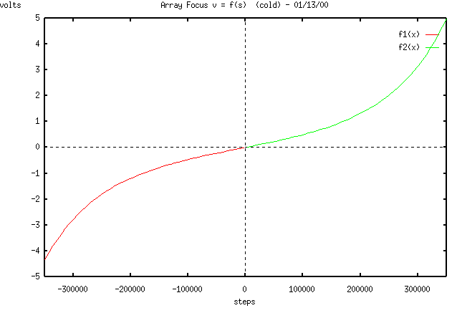
10. Calibration Lamp AC Power Control

10.1 A modified RPC-3 unit is used to control spex’s calibration lamps. The controller board for the RPC3 was removed. The relay are controlled using digital output signal from the RIO Ethernet IO units.

11. Summary of Motor Velocity and Gearing.

