Upgrades to SpeX's Motor, Temperature Control System. $30K.

The SpeX array and readout electronic will be upgraded in 2012. However, this upgrade proposal does not include any funds to upgrapde SpeX's instrument control hardware. This hardware over 12 years old and will require replacement when Spex's array are upgraded. Hardware includes: one computer, motor controllers, ethernet based IO controller, three temperature controller/monitors, ten motors, two electronic boxes, and power supplies.

1. Computer, littledog

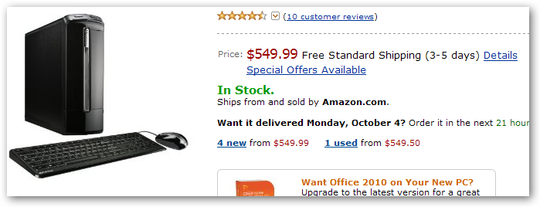
Small Form Factor Computer, Moderate speeed, linuxOS, $550.
2. Motor Controller

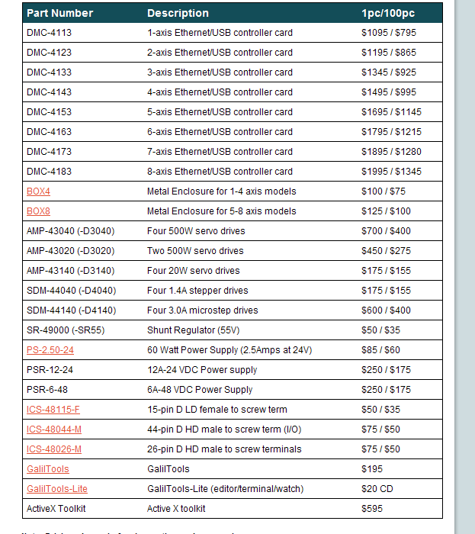

DMC-4183, 8 axis controller, $1995
Metal Enclosure, $125
Power Suppies, $80,
GalilToos $200
Approx $2.5K total
3. Ethernet IO control unit

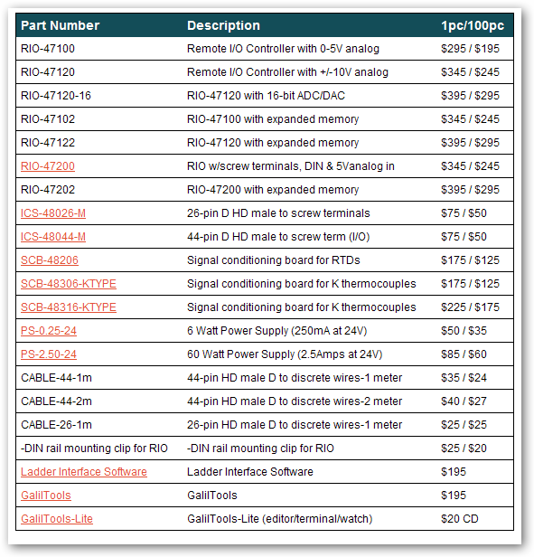

RIO_47122, $400, 2 each
4. DigiPort Terminal Server

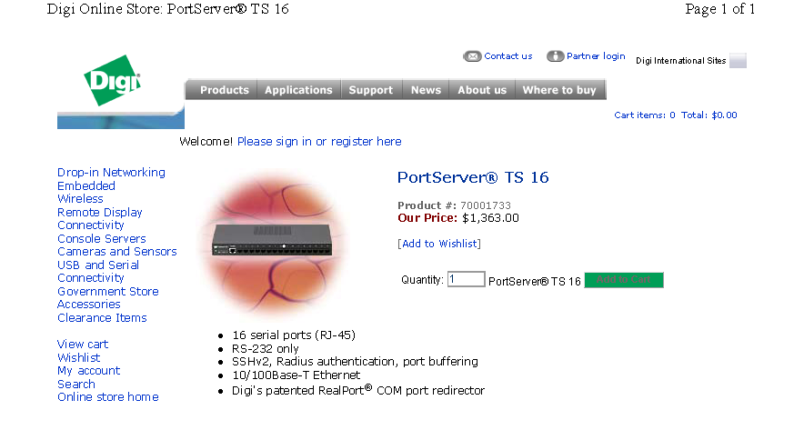

5. WTI IPS-800 AC power control unit.

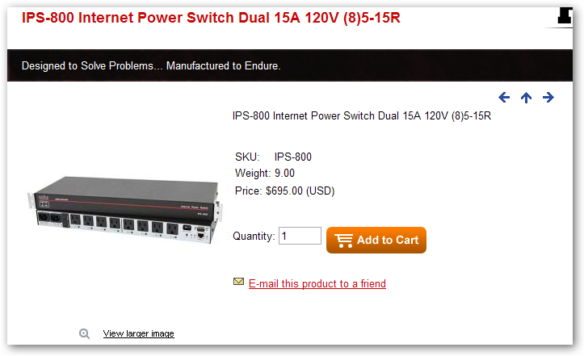
6. Motors

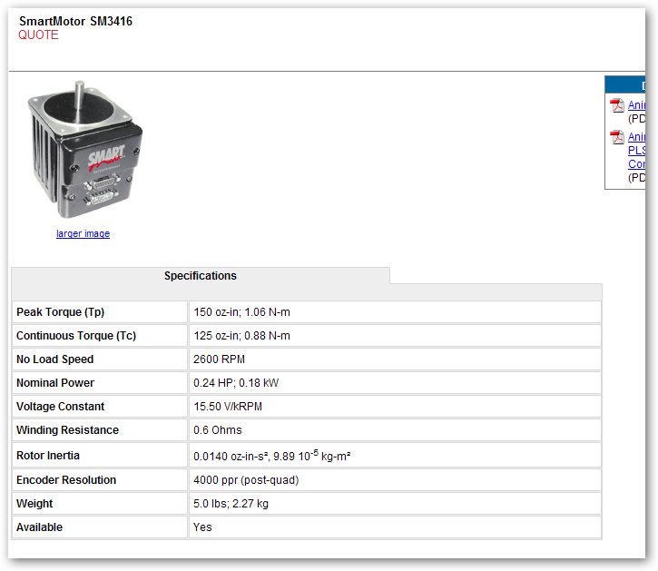

Replace SM3410-V, cost is approx $1200.
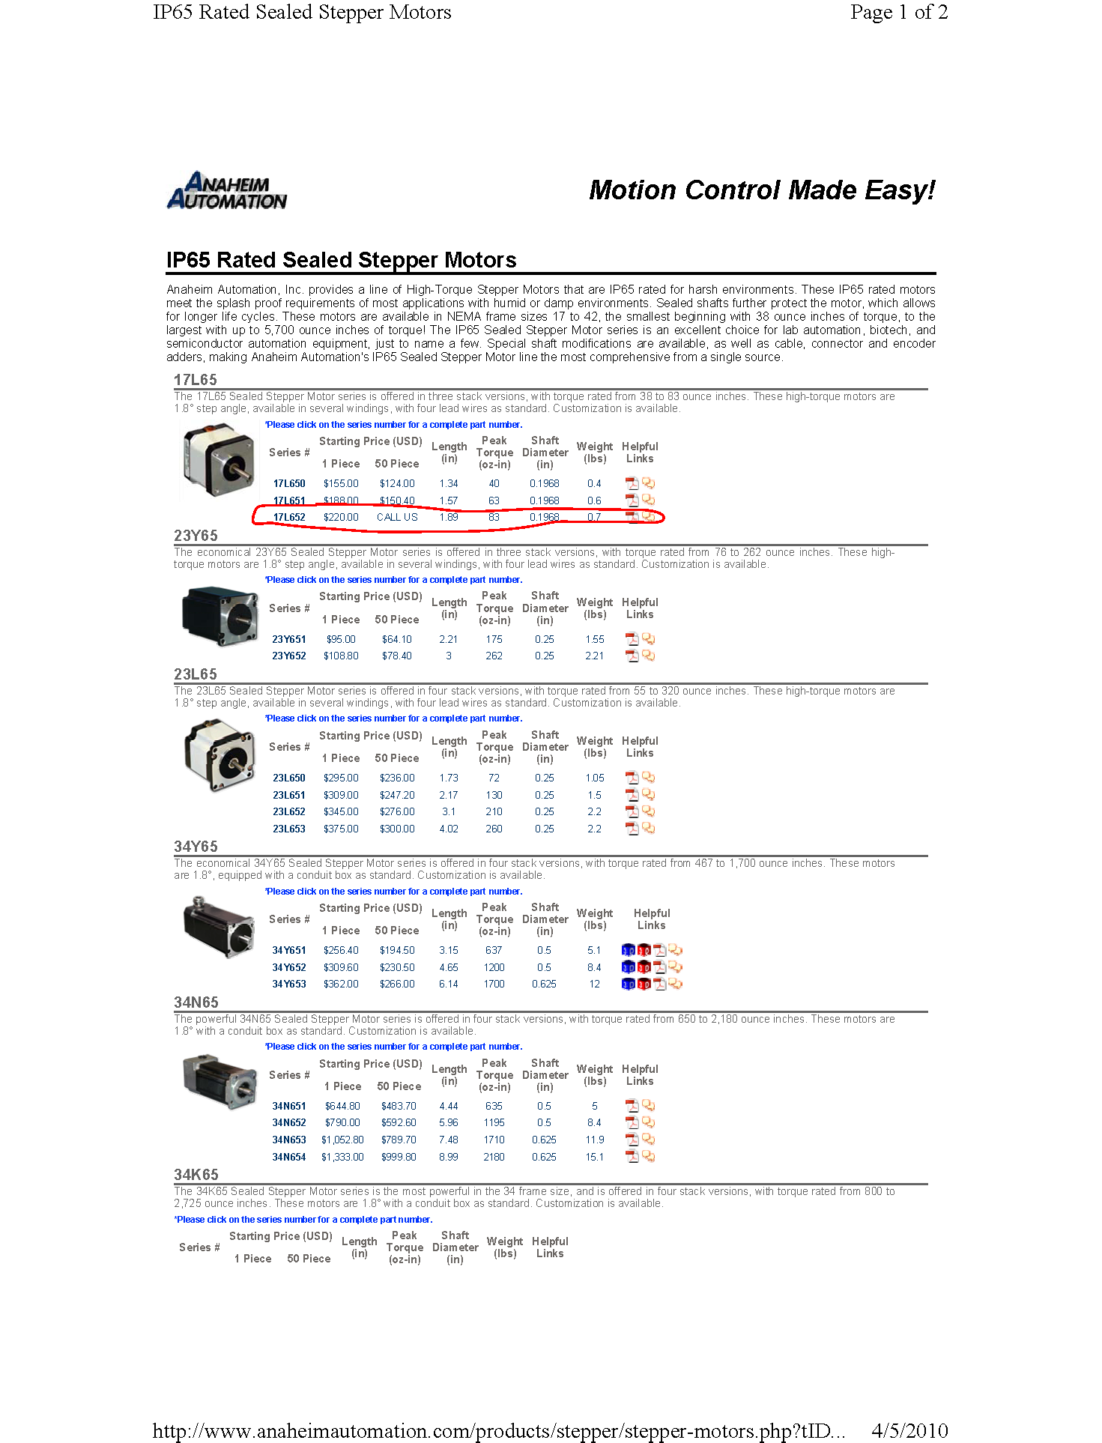

7. Analog Condition/Comparator Board

The analog signal from the Hall Effect sensors used by the mechanism requires conditioning prior to being sample in an A/D or feed into an TTL input. A custom board by the IRTF EE will be build. Estimated cost for board manufacture and parts is $600 per board.

8. Three electronic chassis, and power supplies

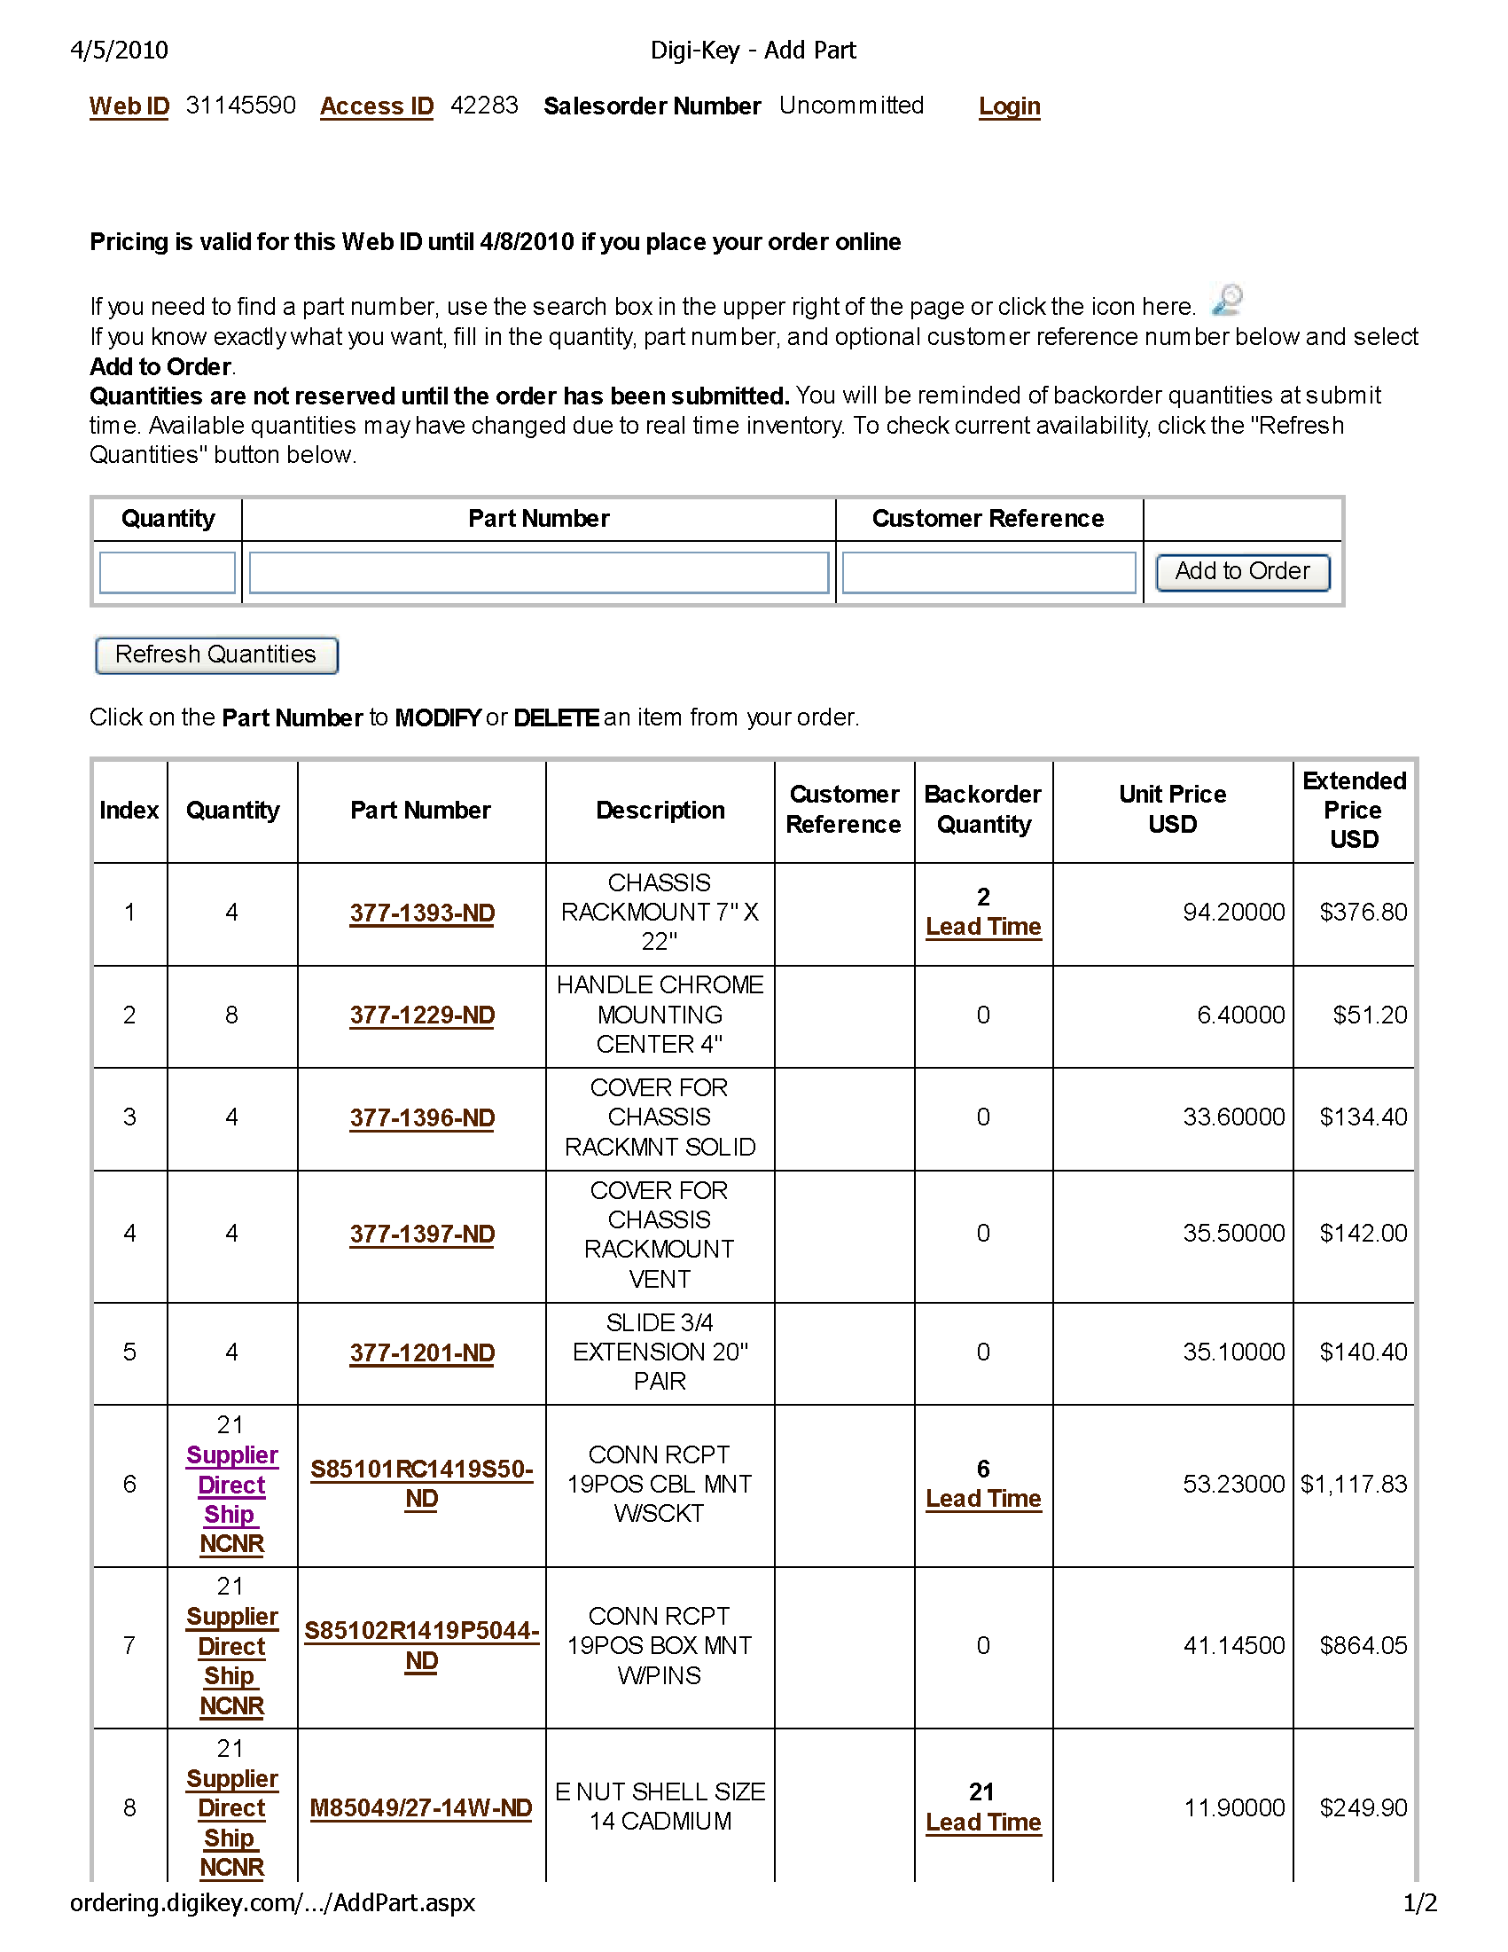
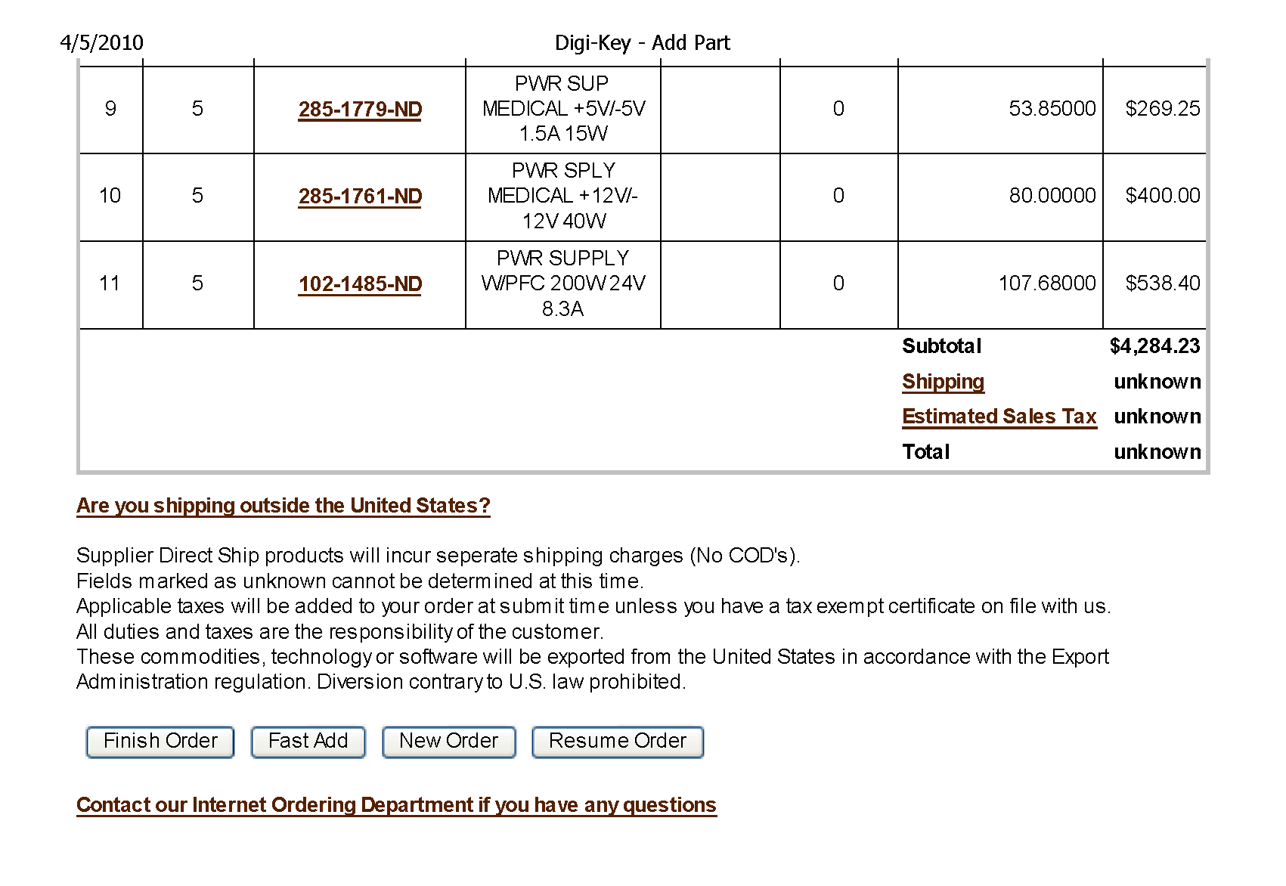

9. Temperature Controllers

