

TCS3 Project

Replacement of the Telescope Control System for the IRTF

Conceptual Design Review

Aug 21, 2003

Table of Contents:

- Schedule, Tasks, and Budget
- Overview
- Computer & Servo Controller
- T3 Electronics
- Encoders
- MCC Replacement
- Facility IO
- Software
- TCS1-TCS3 switching
- RemoteGUI
- Remove TCS1

1. Schedule, Tasks, and Budget

The TCS3 project is organized as a series of Tasks. A schedule, overview of the tasks, and budget is summarized below.

1.1 Schedule

1.2 Task List

1 Task: Conceptual Design.
Project Man-months: 3 (Jun-Aug 03)
Major Milestone: Present Conceptual Design.

2. Task: Build TCS3 computer, servo controller, and servo simulator.

Purchase Servo controller (RA, Dec, Dome).
Purchase Computer System (2 each, summit & hilo Lab/spare system)
Purchase TCS3 Equipment Rack and accessories.
Design/Build T3 Electronics interface
Implement Servo Simulator (Lab test motors)
Develop TO Panel prototype

Project Man-months: 9 (Sept 03 – May 04)
Major Milestone: Control simulated HA, Dec motors using computer, controller, and T3 electronics.

- Task: Encoder Replacement.

Install new absolute encoders.
Install new incremental encoders.
Read the current Dome scanner.
Install computer system at summit.
Acquire encoder data into T3 applications.

Project Man-months: 6 (Oct 03 – Mar 04)
Major Milestone: TCS3 computer system provides HA, Dec, Dome encoding information.

4 Task: Install MCC replacement at summit.

Prep TO area for new T3 Displays and TO Panel. (Preliminary task).
Purchase Facility IO hardware
Develop Facility IO software
Install Facility IO at summit.
Develop MCC replacement T3 Display 1 & Display 2 GUI.
Switch non critical MCC Functions to TCS3

Project Man-months: 6 (Jan – Jun 04 )
Major Milestone: TCS3 used in operations (replacing some non critical MCC functions).

5 Task: Prototype and Build TO Panel

Development of TO Panel prototype (Preliminary task sept 03 – mar 04 )
Construct the TO Panels (2 each, summit and development system).
Install TO Panel at summit.

Project Man-months: 3 (Apr-Jun 04)
Major Milestone: TO Panel completed.

6 Task: TCS1-TCS3 Switching.

Install tcs1/tcs3 switch over Hardware.
Develop switch over procedures.
Switch & test Dome control.
Switch & test HA, Dec Axis Control.
Install new Shutter JBox and control using MCC Display.

Project Man-months: 4 (Jul – Oct 04)
Major Milestone: TCS3 Drives RA, Dec, and Dome successfully

7. Task: RemoteGUI

Purchase computer for portable T3 interface.
Implement RemoteGUI software.

Project Man-months: 3 (Oct – Dec 04)
Major Milestone: RemoteGUI completed.

8. Task: Daytime Test

Schedule Engineering (Daytime) Test:
Switch from TCS1 to TCS3. Test HA, Dec, Dome control.

Project Man-months: 3 (Jan-Mar 05)
Major Milestone: RA, Dec, and Dome servo performance is acceptable.

9. Task: Night Engineering

Pointing calibration: Take pointing data, reduce, and input into TCS.

Project Man-months: 1 (Apr 05)
Major Milestones: TCS3 pointing is calibrated.

10. Task: Remove TCS1

Decommission TCS1
Remove TCS1 equipment.
Remove TCS1-TCS3 Switching equipment.
Remove TCS1 APE and install new T3 absolute encoders.
Remove TCS1 inc encoders, and relocate T3 inc encoders.

Project Man-months: 3 (Aug-Oct 2005)
Major Milestones: TCS1 is removed from IRTF.

1.3 Budget

2. TCS3 Overview

The overview identifies the major component of the TCS3.

Figure 2.1 provides an overview of TCS3

2.2.1 TCS3 Display1, Display2, and TO Panel

The operator’s interface to the T3 systems are Display1, Display2, and the TO panel.
Display1 and 2, along with a mouse and keyboard are the console items to the T1 computer.
The TO Panel is connected to TCS3 Servo Electronics.

2.2.2 T3 Equipment Rack

A 19” equipment rack will be located in the TCS Room, and will house the computer, T3 electronics, Facility IO hardware, and other T3 equipment.

2.2.3 T1 computer

The T1 computer is tcs3 computer system. This will be an x86/PCI computer running the Linux Operating System. A servo controller board will be hosted in a PCI slot.

2.2.4 T3 Electronics

Custom build electronics will interface the T1 computer and TO Panel to the RA, Dec, and Dome servo system.

2.2.5 Facility IO

A general purpose facility IO system will provide the needed analog and digital IO to allow the T1 computer and servo electronics to interface with the facility hardware.

2.2.6 Encoders

New absolute and incremental encoders will be installed in parallel with the TCS1 encoders. TCS3 will use the present bar code system for the dome encoding.

2.2.7 Shutter JBox Replacement

The Shutter JBox will be replaced to allow the shutter control IO to be routed using an Ethernet IO module.
3. Computer System and Servo Controller, and Servo Simulator

3.1 TCS3 Computer

The TCS3 computer is named “T1”. TCS3 will be made up of 1 computer. This host will be located in the TCS3 Rack in the TCS Room.

Figure 1 – TCS3 computer system with servo simulator

Computer description:
4U 19” Rack mount computer case.
Standard x86 PCI motherboard, CD-ROM, Keyboard, mouse, etc.
Operate under the Linux OS. Very likely using a Red Hat Linux distribution.
Support dual video output for the MCC Display1, and Display2.
House a PCI servo control peripheral board to control the HA, and Dec axis.
Communicate with facility hardware via IRTF LAN.

Two systems will be purchased:
“T1” – IRTF TCS3 computer
“T1H” – IRLAB development system / spare.

A network 100/10 switch will also be located in the TCS3 Rack. All TCS3 Ethernet devices would be connected to the switch. The tcs3 switch will connect to the IRTF LAN.

The computer and switch will be housed in a 19” equipment rack. This rack will also provide space for the servo electronics, Facility IO, and other TCS3 equipment. Rack should include fixed or sliding shelf for computer and electronic boxes, and AC power distribution.

2.2 Servo Controller

The RA and Dec axis will be controlled using Galili DMC-18x0 Controller board. The DMC-18x0 is a PCI based servo controller. The 4 Axis controller is targeted. Detail information can be found at www.galilmc.com.

3.3 Servo Simulator

The TCS3 project will build and maintain a simple model of the HA and Dec motors and incremental encoders. Absolute encoding not required. We will build a model of each axis, as illustrated in Figure 2.

Figure 2 – Servo Simulator

Amp: +/- 10v input signal.
Motor: DC motor
Motor rpm: 1200 as/s * 144 / 1296000 as/rev = 0.13 rps.
(7.7 seconds to do 1 rev).
Motor-Bullgear gearing: 144:1 (same as IRTF motor-bullgear ratio, per Tim Bond 6-24-03)
Axis Shaft diameter: TBD
Incremental encoder: 100 pulse/as resolution

The spare dome scanner will be used to develop/test the dome encoding. A simulator is not need for the dome.

3.4 TCS3 Rack

A computer rack will be purchased and assembled. This rack will house the computer, T3 electronics, and Facility IO hardware. Sliding shelf will be used to enable easy access to these electronic boxes. Also include in the rack will be cable mounting hardware, distribution for AC power, and a network switch.

3.4 Cost Estimate

4. T3 Electronics

The T3 electronics refer to the following custom design and build electronics:

- Axis Interface (HA, Dec)
- Dome Interface
- TO Panel Interface

4.1 Axis Interface

The axis interface is custom-built electronics that provide the glue logic between the controllers (servo board, TO Panel) and the motor amplifier. There will be two Axis interfaces: HA Axis Interface, and the Dec Axis Interface. The HA and DEC are identical in function which is shown in figure 4.1.

Figure 4.1

4.1.1 General Description

The primary job of the AI board is to take a motor command signal from the servo controller board, or from a joystick when in manual mode, and drive the axis by outputting the correct voltages to both motor velocity amplifiers. For the HA and DEC axis, one motor will move the axis, while the other maintains a constant anti-backlash force on the opposite motor, based on the direction. This is achieved by splitting the ±10V signal from the motor controller into two separate signals, a 0 to +10V signal and a -10V to 0 signal which then drives two separate power amplifiers.

The second purpose of this board is to gather and distribute the emergency and brake lockout conditions. The safety circuit is shown below in figure 4.2.

Figure 4.2

4.1.2 Modes

The AI board will support the following modes, which are selected by the operator on the TO panel:
Lockout – Control to the motor amplifiers are disabled.
Manual – The control signals for the HA, Dec and Dome are generated from the TO panel’s joystick interface. Velocity is limited to 400 as/s.
Standard – The Standard is the computer-controlled mode. The control for the motor amplifiers come from computer’s servo controller board.

4.1.3 Limits

Each axis has a Slew, Stop, and Brake limit. The AI will react to the limit as follows:

Slew – The velocity output to the motor amps be limited to tracking velocity (400 as/s).
Stop – The velocity output to the motor amp will be adjusted to a rate of zero.
Brake – The velocity output to the motor amp will be adjusted to a rate of zero and the brakes on the motor will be engaged. Emergency state will be enabled.

The state of the stop limit will be input into the servo controller’s axis limit input. The limit override on the TO panel will disable all 3 limits.

4.1.4 Emergency

The Emergency condition occurs when:
1- Brake limit is enabled.
2- Emergency input is enabled. (There are two inputs: TO panel, software input via Facility IO)
3- Over-Current or Over-Temperature error from Amps.

When the emergency condition is active the motor commands to the amplifiers are shut off, and the brakes are engaged. The emergency condition is reset from the TO Panel reset button or facility IO reset input.

4.1.5 General Indicators

Output for indicators and monitoring are needed for the following:

Indicator | TO Panel | Facility IO
Mode (Manual, Standard) | Y | Y
Limit Override | Y | Y
Emergency | Y | Y
Slew Limits | Y | Y
Stop Limits | Y | Y
Brake Limits | Y | Y
Motor brake on | Y | Y
Motor Current | N | Y

4.2 Dome Interface

The function of this servo interface is similar to the HA and DEC axis with the exception that this controller drives the servo amplifier in both directions by supplying a ±10V signal to the amplifier. The dome interface is shown in figure 4.3.
Figure 4.3
4.3 TO Panel Interface

The function of the TO board is to interface to the TO panel components which is shown in Figure 4.4. These components include:
- HA, DEC, and Dome hand paddles.
- Emergency stop button with a reset
- Key switch with the Lockout, Manual, and Standard positions
- Brake control and reset switch, which will also control the switched AC line breaker.
- LEDs to indicate: slew, stop, and brake limits, Zenith, emergency, and other conditions
Figure 4.4
4.4 Cost Estimate

We expect to design 2 boards: 1) HA, Dec, and Dome Axis Interface. 2) TO Panel Interface.
We estimated 3 runs for fabrication of the circuit boards: 2 prototypes, and a final production run.
5. Encoder Replacement

5.1 Top Level Encoder Requirements.

The encoder requirements for the new TCS are as follows:

Absolute position resolution: 1.0 arcsec [0.1 arcsec goal]
Incremental position resolution: 0.01 arcsec
Maximum slew rate: 1200 arcsec/sec on sky [2000 arcsec/sec goal]
Maximum slew acceleration: 1200 arcsec/sec²
Environment: -10 to 50 deg C.
Humidity: 100% Relative Humidity.

The old TCS is currently unsupported and the implication of this is that we cannot modify any of the existing encoding hardware, until after the new encoders are commissioned. Unfortunately, the old encoders are installed at the best locations (easy access, stiffness, protected, etc.) on the telescope.

5.2 Current DEC and RA Absolute Encoding.

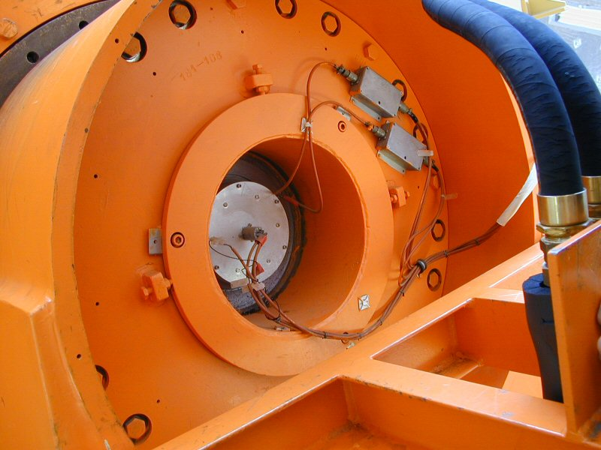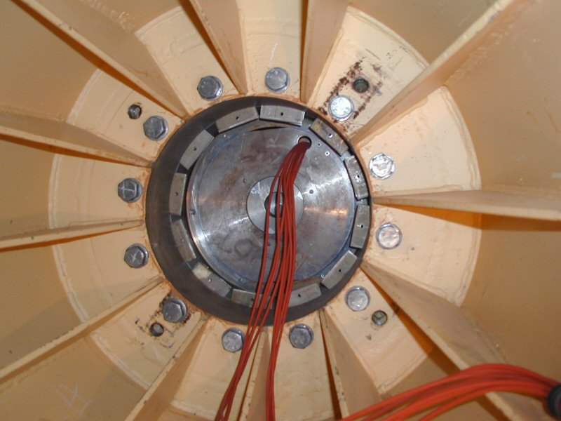
RA APE DEC APE

The current RA absolute position encoder (APE) is located in the North Pier. It is an inductosyn encoder with one half mounted on the yoke, and the other half mounted to the pier.

The DEC APE is located in the west arm of the yoke. It is also an induction type encoder (identical to the RA encoder) with one half mounted to the telescope central section, and the other half mounted on the yoke.

Both of the current APEs have a resolution of 0.1 arcsec.
5.3 Current DEC and RA Incremental Encoding.

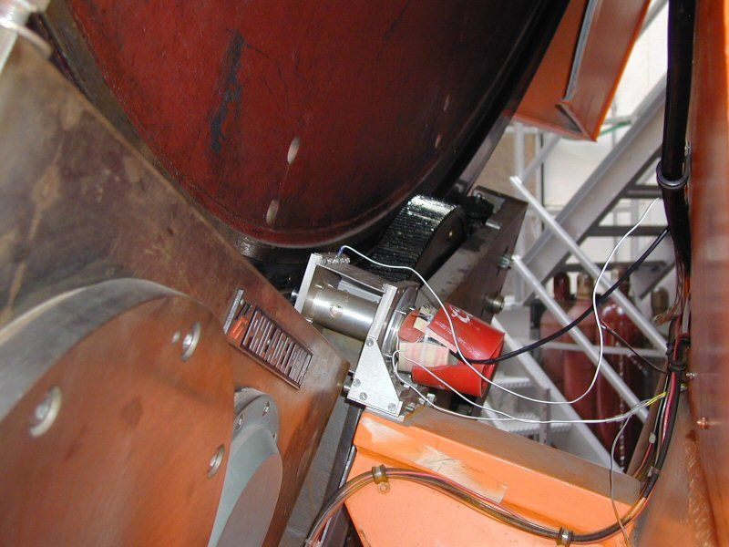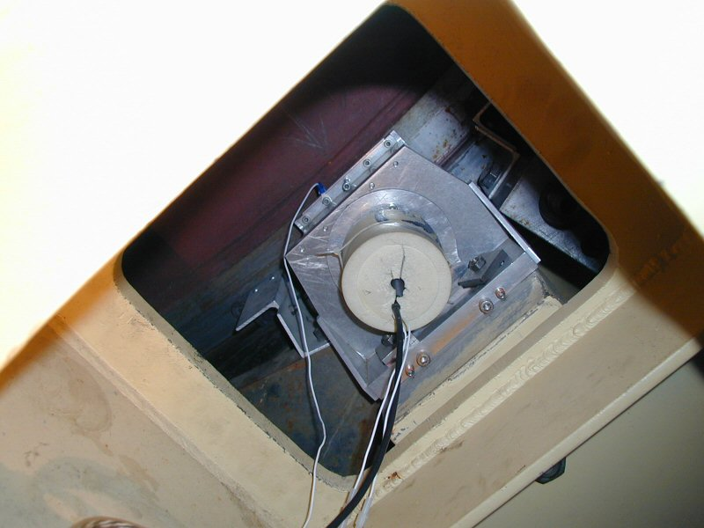
RA Inc. Encoder Dec Inc. Encoder

The current RA incremental encoder is located on the South Pier. It is an optical type encoder (manufacturer – Teledyne Gurley) driven through (approximately) a 180:1 gear ratio friction drive on the back of the bull gear.

The current DEC incremental encoder is located in the west arm of the yoke and access is from inside the yoke. It is also an optical type encoder (identical to the RA encoder) also driven through (approximately) a 180:1 gear ratio friction drive on the back of the bull gear.

Both of the current incremental encoders have a 3600 line count and associated electronics capable of 40x interpolation for a total of 144 000 pulses/ revolution. After accounting for the gear ratio, this works out to about (3600 x 40 x 180) / (360 x 60 x 60) = 20 pulses per arcsec or 0.05 arcsec resolution.

*** Currently, the exact gear ratio is determined through a calibration procedure and works out to be about 19.9041?!?

5.4 TCS3 Absolute Encoding

Due to the fact that the current APEs are located in the optimal position for absolute encoding, and the fact that we cannot disturb these encoders until the new TCS3 has completed commissioning, it will be necessary to install temporary absolute encoders. Once the new TCS3 system is commissioned, the encoders will be migrated to the current absolute encoder location.

These temporary absolute encoders will be installed on the bull gear through a friction drive. This is a less than ideal situation since they could be subject to slippage or error stack-up at the friction drive. Since the encoder will be driven through the friction drive at an approximate gear ratio of 150:1, it will be necessary for the encoder to yield positional information on its angle as well as information about its number of turns.

The hardware required for the temporary absolute encoder will be similar (if not identical) to the hardware fabricated for the incremental encoders.

A possible candidate for the temporary absolute encoder is the Gurley model A23S Absolute Encoder:

Resolution: 8192 words/turn
# of resolved turns: 256
gear ratio of 150:1

Yields 1 228 800 counts / rev of the bull gear
0.948 counts / arcsec on the sky
approx. 1.0 arcsec resolution

The new “final” absolute encoders will optical encoders and will be located in the current APE positions. There are many encoders on the market that will easily meet our requirements.

A possible candidate for the final absolute encoder is the Heidenhain RCN226 Absolute Angle Encoder:

67 108 864 position values / rev (26 bits)

Yields 51.78 counts / arcsec on the sky
0.0193 arcsec resolution

5.4 TCS3 Incremental Encoding

Similar to the case of the absolute encoders, the current incremental encoders are located in the optimal position. The fact that we cannot disturb these encoders until the new TCS3 has completed commissioning will make it necessary to install temporary incremental encoders. Once the new TCS3 system is commissioned, the encoders will be migrated to the current incremental encoder location.

These temporary absolute encoders will be installed on the bull gear through a friction drive and identical to the final encoder compliment. Since the encoder will be driven through the friction drive at an approximate gear ratio of 150:1, specialized hardware will have to be fabricated to provide alignment and tensioning. Every effort will be made to make the fabricated hardware for the temporary configuration identical to the hardware required for the final configuration.

Since the TCS3 computer may adjust the servo velocity based on positional error measured at 10 Hz, a resolution of 100 Hz (10 x 10 Hz) is highly desired.

A possible candidate for the incremental encoder is the Gurley Series 8235S rotary incremental encoder, along with series HR2A high resolution interpolator:

Line count = 11250 lines/rev
Interpolation = 80x
Gear ratio of 150:1

Yields 135 000 000 counts/rev of the bull gear
104.167 counts / arcsec on the sky
approx. 0.01 arcsec resolution

Also slew rate of 1200 arcsec/sec = 125 000 counts/sec (emerging from electronics)
(125 000 counts/sec) / (80) = 1562.5 Hz (emerging from encoder)

It would be desirable to find an encoder with higher resolution. This would allow us to work with a smaller gear ratio, mitigating many of the errors/problems that are associated with the friction drive. Several higher resolution encoders from Heidenhain will be investigated.

5.3 Current Dome Encoder

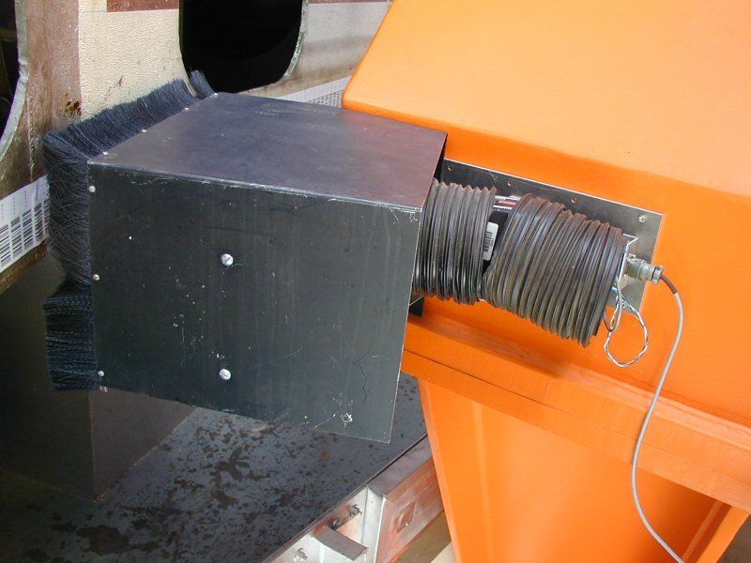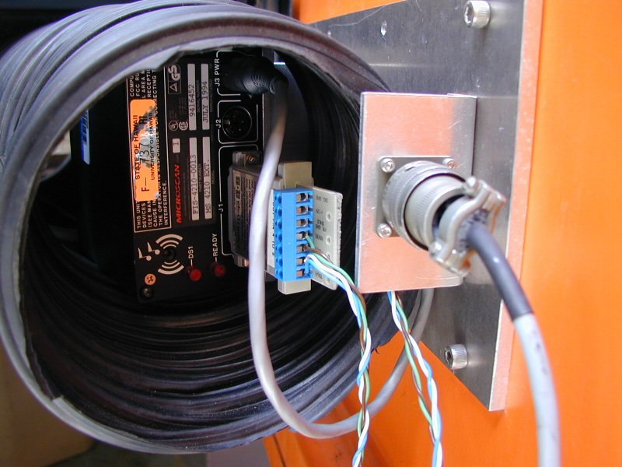
Dome Scanner (side view) Dome scanner (back)

The dome is encoded using a bar code label and a scanner. The scanner outputs is serial (RS-232?). The serial is converted into a parallel graycode using an embedded CPU board.

The barcode values range from 1 to 1800, giving the dome a resolution of 0.2 degrees.

5.5 Budget / Manpower

The IRTF will provide the mechanical, electrical, and software support via Bond, Keske, and Denault.

Initial cost estimates are as follows:

6. MCC replacement

6.1 TCS1 MCC1

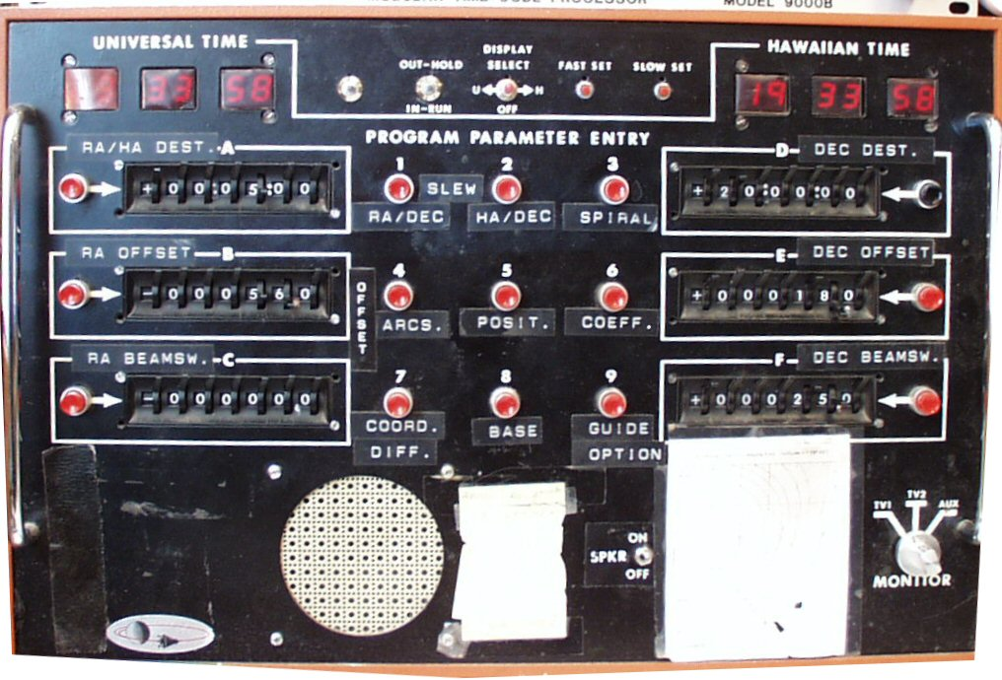

Universal time and Local time to be displayed on tcs3 graphics window.

All functions can be implemented using software commands.

The speaker is used to issue beep for operator feedback.

6.2 TCS1 MCC2

MCC2 control/display is mostly related to the TCS servo functions (RA, Dec, DOME).

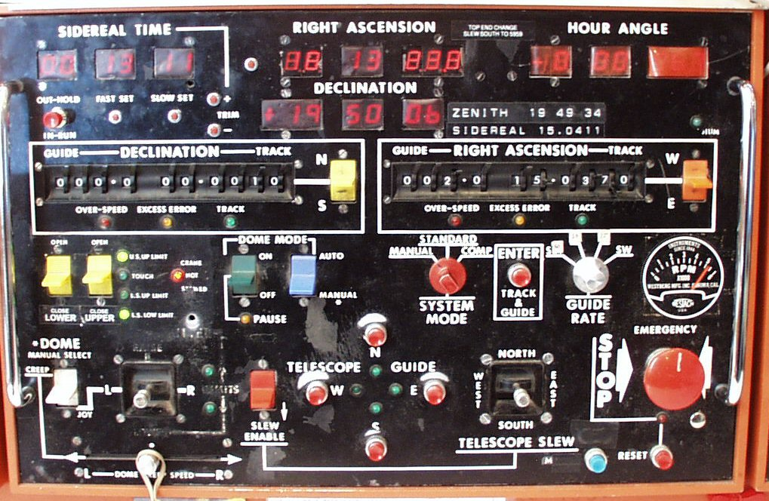

Note from MCC meeting:

- Safety issue – In the past the computer had shutter control. This was disabled, the shutter can only be controlled via the MCC. The LED indicated when the shutter has reached its destination. Communication to the shutter is via slip ring. The IRTF has 7 slip ring:
1-3. Power ( 3 Phases)
4. GND
5. Neutral
6. Tone Modem UP. Control signals for lights and shutter.
7. Tone Modem Down. LED switch for shutter position.
8. Signal GND.

MCC2 functional description table

6.3 TCS1 MCC3

MCC3 s used mostly for Facility IO and TCS function not directly related to the servo.

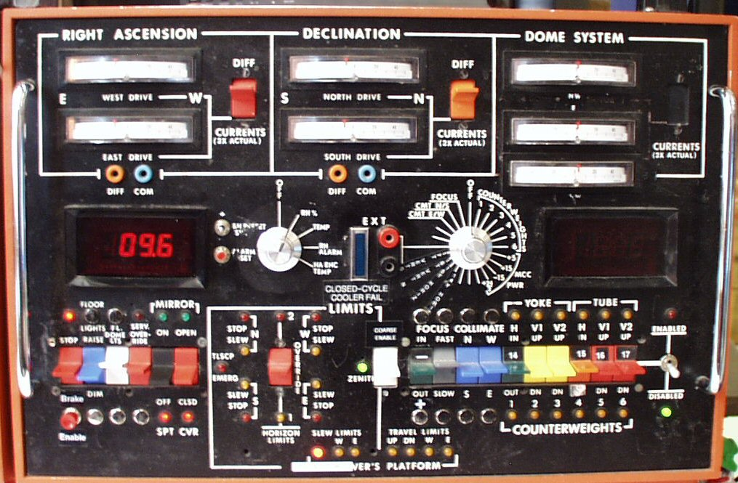

- Dave and George suggested that we have a way of saving and recalling counterweight configurations. Multiple configurations are needed for various instrument configurations.

- Limits. The RA DEC axis has 3 limits controls:

  - Slew – This limits the velocity current from slew (1200 as/s) to track (400 as/s) speed.
  - Stop – This sets the velocity current to zero.
  - Brakes – This turns on the brakes. The disable this limit, a override card is plugged into the qBus.

These are safety function provide by the tcs electronics. not software algorithms. TCS3 will need to preserve these limits; however the brake override can be a switch in the tcs3 electronic. The tcs3 software should monitor the tcs3 brake override.

3. Not shown is a mirror support air pressure input. The is a Analog voltage. A serial based DV Monitor box is installed. Currently this data is not monitored or recorded. TCS3 will probably acquire the analog Input (not use the serial monitor).
MCC3 Functional Description Table

  - Staff Input

6.4.1 David Griep

Need to move the Telescope to Zenith (with eyeball accuracy) independent of computer control.
Need to move the dome independent of computer control.
Need to move the shutter independent of computer control.

For new TO Pannel, use a single RA and DEC joy stick.
Need Floor light on TO panel for Emergency.
  - TCS3 MCC replacement

The MCC3 MCC replacement will visually consist of 2 computer monitors and a TO Panel. Normally the TCS3 computer will be booted up and running at all times. The TCS3 computer will have 2 monitors, in each monitor a GUI window will access to the various MCC functions. The TO Panel will be a hardware panel with controls and indicators to directly control the TCS3 electronics.

The tcs1 and tcs3 system will coexist for approximately 1 year. Since space is extremely tight in the TO area, the TCS3 MCC replacements need to be compact. While the tcs1 and tcs3 systems coexist, the TCS3 displays and TO panel may be located just in front of the current MCC panels.

6.6 Prepare TO area for new MCC Displays and TO Panel

Some effort will made to improve the TO area to better accommodate the MCC displays and TO panel. Most likely, we will replace the folding table the TO’s use for Max with a larger (real) table, and improving the equipment organization near the current MCC.

6.7 TCS3 Display 1

TCS3 Display 1 will concentrate on items directly related to the RA, Dec, and Dome servos. It provides functions similar to MCC2. Below is an illustration of what this display could look like.

6.8 TCS3 Display 2

TCS3 Display 2 sill concentrate on items that are peripheral to the TCS – Facility control and monitoring. It provides functions similar to MCC3. Below is an illustration of what this display would look like.

In the above example, the current are always displayed. Below the RA, DEC, and Dome current widgets, tabs would allow selection of various screen formats. Each tab could be related to a TCS task. This example displays the balance tab.

6.9 TO Panel.

The TO panel is hardware panel with critical indicators and controls. Ideally it would be about the size of a computer monitor (16”x16”x 10”). It would be physically attached to the TCS3 electronics rack with a cable long enough to be easily positioned and moved around in the TO’s area.

TCS Electronic Modes
Lockout – disables any movement to Ra, Dec, Dome motors.
Manual – Allow for manual velocity using the velocity joysticks.
Standard – Computer control of RA, Dec, Dome velocity is the standard operating mode.

Slew Limits
Each axis displays the slew and stop limits.
Emergency LED on if brake limit are on.
Limit Override switch makes TCS electronics to ignore limit inputs (slew, stop, brake).

TCS brakes – switch to turn on/off. Must use enable button to accept changes.
Emergency Stop – Pressing will disable all velocity and set telescope brakes.

6.10 Cost Estimate

During the Lab development (Sept 03 – Mar 04) a prototype TO panel will be developed.

Apr-Jun 2004, the actual MCC2 panels (summit and lab) will be machined.

7. Facility IO

The Facility IO refers to facility monitoring and control outside of the core TCS control (HA, Dec, Dome servos). We have compiled a list of the current facility IO, and are summarized in the following table.

Our Facilty IO list is located at: http://irtfweb.ifa.hawaii.edu/~tcs3/systems/tcs3/0306_conceptual_design/07_FacilityIO

We have established the following Facility IO requirements:

- 10 Hz update rates
- Additional IO can be easily added.
- Widely used in Industrial Automation
- Wide variety of the IO options.
- Ethernet based interface

7.1 Opto22

We have selected the Opto 22 (www.opto22.com) SNAP Ultimate IO to be used for the Facility IO hardware. These devices are similar to products such as Advantech’s ADAM-5000/TCP and SixNet Industrial IO. They all consist of a proprietary bus that can accept a series of IO modules. Control and communication is performed from a control unit. Opto22 had the best balance of available IO module, software support, vendor technical support, and cost.

The Opto 22 unit consist a Module Rack ( ~4.5”x15”), controller unit (“Brain”), and up to 16 IO modules. Each IO module can have 4 IO points (64 IO per points per rack).

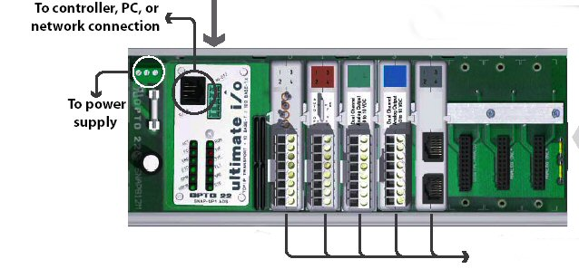
Figure 1 – SNAP module, with brain and IO modules.

The T3 Electronic Rack will house 3 or 4 Opto22 units that will handle the bulk of the IO requirement. An additional Opto22 unit is required for the new shutter JBox interface.

T3 Rack: 3 unit x 64 points = 192 points.
Shutter : 1 unit
Lab: 1 test units
Spare: 1 unit.

7.2 Estimate cost

Estimate includes 4 TCS3 unit, 1 lab units, 1 dome unit, and 1 provisional.
8. Software Design

8.1. Notes on computer variables, their ranges and precision.

These values were obtained using solaris 2.6 on SPARC Iii, gcc version 2.7.2.

Type | Bits | Signed Range | Unsigned Range
Char | 8 | -128 to 127 | 0 to 255
Short | 16 | -32768 to 32767 | 0 to 65535
Long | 32 | -2147483648L  2147483647L | 0  4294967295U
Long Long | 64 | -9223372036854775808L  9223372036854775807L | 0  18446744073709551615UL
Float | 32 | 23 significant bits in mantissa, 6.92369 significant digits in decimal number.
Double | 64 | 52 significant bits in mantissa, 15.6536 significant digits in decimal number.

Positions can be stored in double as radians. 360 degrees = 2.683185307 radians. At 15 significant digits, the resolution is better that 5 nanoarcseconds.

Time can be stored in double as Modified Julian days. MJD has 5 decimal digits, leaving 10 fractional significant digits. This gives accuracy to better that 10 microseconds. For the TCS to 1ms accuracy is sufficient.

8.2. Notes on Limits.

Base Position:

Offset

Servo Position Limits:

Servo Velocity / Acceleration Limits

8.3. General Software Guidelines

- Development and deployment on a Linux OS/x86 system.
- All application written in C – minimize the use of other computer languages.
- Astronomy calculations algorithms are done using slalib or TCSpk.
- Pointing correction to be based on the TPOINT software application.
- GUI is written using GTK+
- Use the POSIX API for system and clib calls, shared memory, message queues, scheduling and processing control.
- Berkeley Socket API and remote procedures call (RPC) are used for network libraries.

8.4. Position Table

During normal operation (Tracking) the TCS position is indicated by the position table. Here is an illustration of the information for the position table.

CS is the Coordination System, which can be FK5, FK4, and Apparent.
Equinox is the equinox of the coordinate system.
Epoch is set to the current date.
Base is the RA, Dec position.
Base position can have a rate.
There are 3 offsets ( User, Beam switch, Scan)
Scan can be controlled using commands like:
Scan.go ra, dec ra_rate dec_rate
The target equals Base + Offsets.

Other implementation Notes:

TO request 3 next buffer: TO, obs, cat
Base command limited to +/- 3600 as from current base.
Slew command allows any base value to be entered (within telescope range of course).
8.5. Mean to Mount Calculations

This table illustrates the coordinate transformations from user inputs to mount position.
8.6. Pointing Correction

The pointing correction will be based on TPOINT. Information on TPOINT can be found at www.tpsoft.demon.co.uk

The following TPOINT terms will be supported.

IH - Index Error in Hour Angle
ID - Index Error in Declination
NP - HA/Dec Non-perpendicularity
CH - East-West Collimation Error
ME - Polar Axis Misalignment in Elevation
MA - Polar Axis Misalignment in Azimuth
FO - Fork Flexure
HA - Centering Error, Sine Component
DCES - Dec Centering Error, Sine Component
TF - Tube flexure (sine)
TX - Tube Flexure (tangent)

8.7. RA, DEC Servo Modes - The following RA, Dec servo mode will be implemented.

Idle – No active servo control being performed.

Time information is calculated.
Velocity of all motors (ra, dec, dome) will be set to 0.
Encoder are read and a reverse mount->Target positions are calculated.
All rates & Offset parameters are set to 0.

Track – Track based on the Target position from Position Table.

Time information is calculated.
Rates are applied to base and offsets.
Coordinates transformation Target RA,Dec -> mount are calculated.
Servo task will command motors to this position.

Slew – High speed move to Target position from Position Table.

Same as track, but increase velocity limits from 400 ac/s to 1200 as/s.

Motor Position – Point to point motor using axis coordinates.

Time information is calculated.
Encoder determines telescope position
Reverse transformation mount->Target is calculated.
Motor velocity can be specified.

Motor Velocity – Jog type motor command.

Time information is calculated.
Encoder determines telescope position.
Reverse transformation mount->Target is calculated.
Motor velocity can be specified.

8.8 Dome servo modes. The following Dome servo mode will be implemented.

Manual - Operator can increment or decrement dome position.

Auto - Dome will track the Azimuth of the TCS, and auto position the dome.

8.9 Shutter

Shutter control / feedback will be the same are the current system.

8.10 Facility communications

Communication to TCS3 will be done using TCP/IP and/or UDP. Communication based on a ‘serial line interface’ method - text command and replies using a simple command language.

A socket based terminal IO should is one option to connect to the tcs3. This is a stream based network socket. The full command set will be supported over the TCP/IP link. Multiple telnet sessions into the TCS will be supported.

An RPC daemon will support UDP type commands/queries. This will provide a limited command set. Very verbose and interactive commands will be disabled. However, this connect-less protocol will support a higher rate of exchange and much quicker individual performance.

8.10 TCS3 Application Block Diagram

IC – T3 software application. Creates system resources (ie: shared memory) and start all T3 sub-processes.

Timer – control task to schedule time critical task.

Vtcs – Virtual TCS task does astronomical calculations. Calculation loop is 20 Hz.

Rtcs – Real TCS task is responsible for positioning the RA, Dec axis through the servo controller board. A 20 Hz task.

ttd – T3 Telnet Daemon allows sock connection to T3 command interface. Multiple socket connections allowed.

t3.rpc – Alternate network interface to t3 commands using RPC.

Pfast – A fast periodic task – general purpose fast execute loop (1 to 10Hz).

Pslow- a slow periodic task – general purpose execute loop (>1 Hz).

Fio – Facility IO tasks to monitor and control the facility IO hardware. A 10 Hz update loop.

T3D1, T3D2 – X based display for MCC-like displays.

TO GUI – The TO GUI is a X based display application. This is what the TO will run on Max.

T3 Remote GUI – A simpler GUI for remote observing and as a portable TCS interface.
9. TCS1-TCS3 Switching

We need to switch between TCS1 & TCS3 to driver the RA, Dec, and Dome servo systems. The switch back fairly quickly and easily. This will enable daytime test runs and night time engineering with using TCS3, while keeping TCS1 operational.

The new encoders and the replacement MCC (using computer display) should be operational by this point in the project. This should minimize the number of signals to be switched.

This task should be fairly straight forward, not posing any great technical challenges. At the required time we will survey the signals to be switched, purchase or build the necessary hardware, and install them.

9.1 Shutter Controller

The JBox for the shutter IO interface needs to be changed. The current JBox communicates over the slip ring using the tone modem equipment. We wish to decommission the tone modem equipment.

The new JBox will be connected directly to a Opto22 device. This opto22 will connect to the network using the Shutter hub installed as part of the IQUP project. This Hub is connected to the IRTF Lab using X10 device to traverse the slip rings.

9.2 Schedule and Budget

Tcs1-tcs3 switching is scheduled for Jul-Oct 04 (4 month). The achieved milestone is to have the T3 system drive the HA, Dec, and Dome successfully. The shutter control will be transferred to the new MCC.

We allocated $20K for the tcs1-tcs3 switching and shutter control hardware.
10. T3 Remote GUI

The T3 Remote GUI is a scaled down graphical interface for the TCS to be used by:

- Summit Observers
- Remote Observers
- Day Crew (or by anyone running the TCS away from the TO area).

This application will displace the need for a custom hardware panel. Advantage of using a software GUI vs. Hardware panel are:

- No custom Hardware to purchase and maintain
- No custom software (embedded OS, tool, application) needed.
- Additional expertise required for customized solution is not needed.
- Software GUI is easily to modify and maintain.
- Application runs on a generic portable computer.

The close example to our RemoteGUI would be the tcs1_status application current being used at the IRTF. The T3 RemoteGUI would support additional function, quicker response due to the improved network communication infrastructure provide by the TCS3

Figure 10.1 – Current tcs1_status application

10.1 Cost Estimate

2 laptop X $3K = $6K

11. Remove TCS1

Once the T3 is accepted as the operational TCS, TCS1 can be removed. The following major tasked are identified:

- Remove TCS1 Equipment including MCC panel.
- Remove TCS1-TCS3 switching equipment.

- Implement final configuration of the encoders.

$15 K has been reserved in the budget for any final task associated with removing the old TCS.

