6. MCC replacement

6.1 TCS1 MCC1

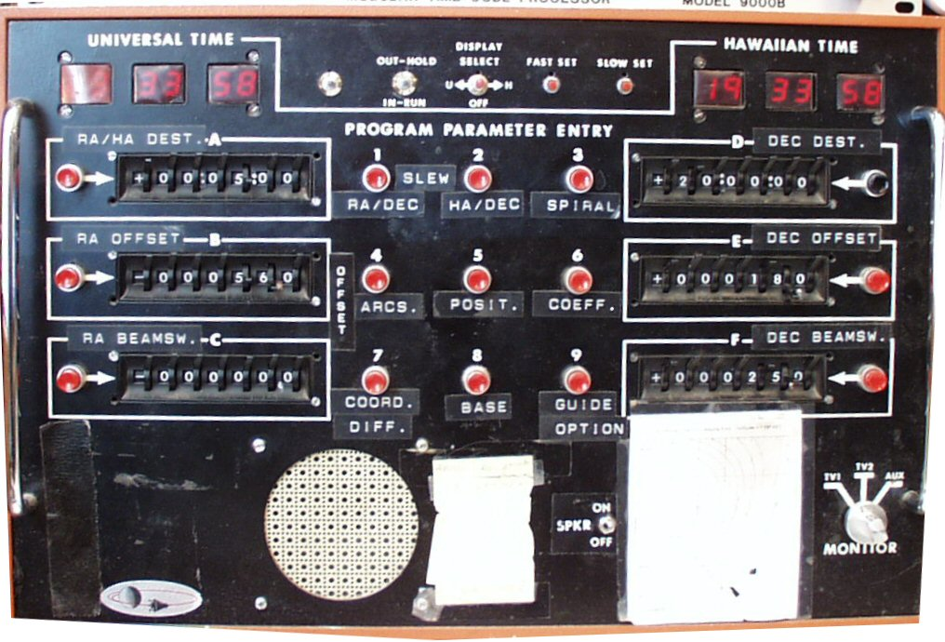

Universal time and Local time to be displayed on tcs3 graphics window.

All functions can be implemented using software commands.

The speaker is used to issue beep for operator feedback.

6.2 TCS1 MCC2

MCC2 control/display is mostly related to the TCS servo functions (RA, Dec, DOME).

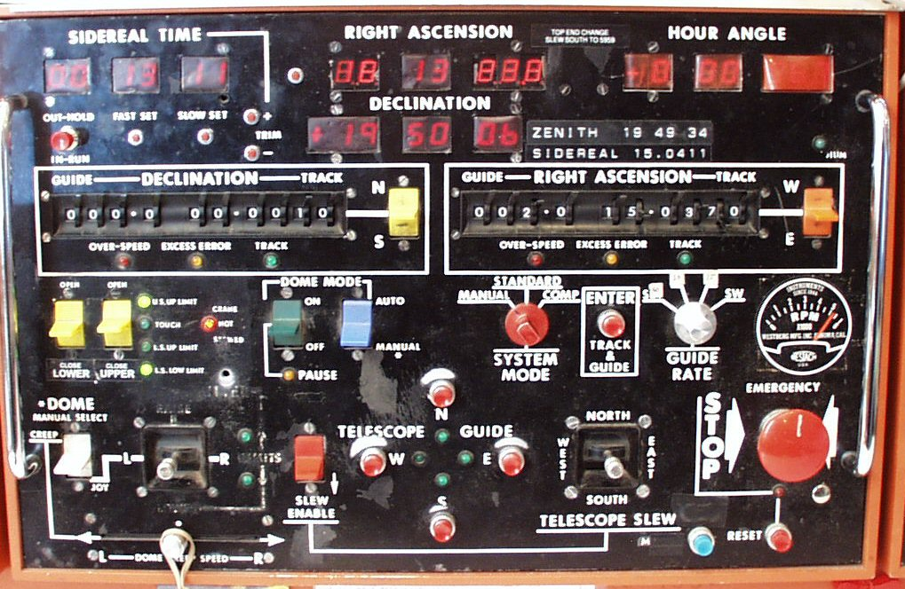

Note from MCC meeting:

- Safety issue – In the past the computer had shutter control. This was disabled, the shutter can only be controlled via the MCC. The LED indicated when the shutter has reached its destination. Communication to the shutter is via slip ring. The IRTF has 7 slip ring:
1-3. Power ( 3 Phases)
4. GND
5. Neutral
6. Tone Modem UP. Control signals for lights and shutter.
7. Tone Modem Down. LED switch for shutter position.
8. Signal GND.

MCC2 functional description table

6.3 TCS1 MCC3

MCC3 s used mostly for Facility IO and TCS function not directly related to the servo.

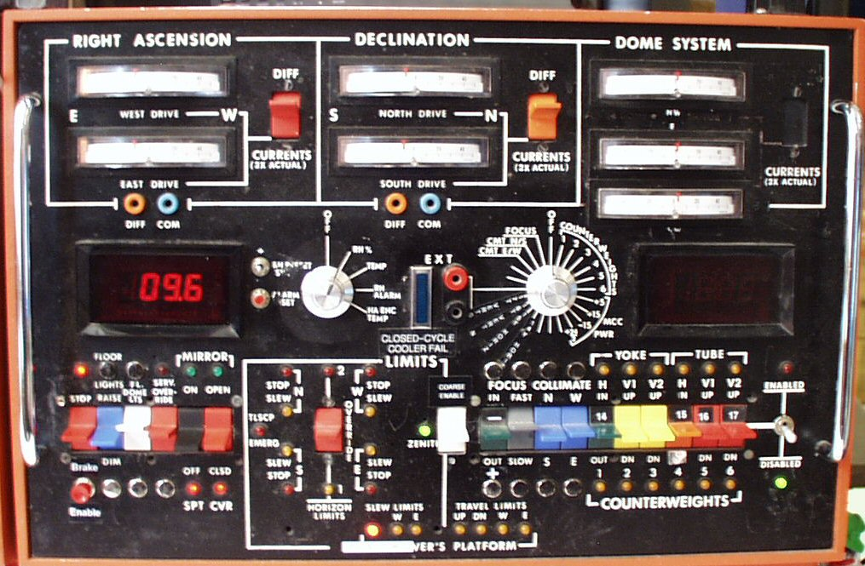

- Dave and George suggested that we have a way of saving and recalling counterweight configurations. Multiple configuration are needed for various instrument configurations.

- Limits. The RA DEC axis has 3 limits controls:

  - Slew – This limits the velocity current from slew (1200 as/s) to track (400 as/s) speed.
  - Stop – This sets the velocity current to zero.
  - Brakes – This turns on the brakes. The disable this limit, a override card is plugged into the qBus.

These are safety function provide by the tcs electronics. not software algorithms. TCS3 will need to preserve these limits; however the brake override can be a switch in the tcs3 electronic. The tcs3 software should monitor the tcs3 brake override.

3. Not shown is a mirror support air pressure input. The is a Analog voltage. A serial based DV Monitor box is installed. Currently this data is not monitored or recorded. TCS3 will probably acquire the analog Input (not use the serial monitor).
MCC3 Functional Description Table

  - Staff Input

6.4.1 David Griep

Need to move the Telescope to Zenith (with eyeball accuracy) independent of computer control.
Need to move the dome independent of computer control.
Need to move the shutter independent of computer control.

For new TO Pannel, use a single RA and DEC joy stick.
Need Floor light on TO panel for Emergency.
  - TCS3 MCC replacement

The MCC3 MCC replacement will visually consist of 2 computer monitors and a TO Panel. Normally the TCS3 computer will be booted up and running at all times. The TCS3 computer will have 2 monitors, in each monitor a GUI window will access to the various MCC functions. The TO Panel will be a hardware panel with controls and indicators to directly control the TCS3 electronics.

The tcs1 and tcs3 system will coexist for approximately 1 year. Since space is extremely tight in the TO area, the TCS3 MCC replacements need to be compact. While the tcs1 and tcs3 systems coexist, the TCS3 displays and TO panel may be located just in front of the current MCC panels.

6.6 Prepare TO area for new MCC Displays and TO Panel

Some effort will made to improve the TO area to better accommodate the MCC displays and TO panel. Most likely, we will replace the folding table the TO’s use for Max with a larger (real) table, and improving the equipment organization near the current MCC.

6.7 TCS3 Display 1

TCS3 Display 1 will concentrate on items directly related to the RA, Dec, and Dome servos. It provides functions similar to MCC2. Below is an illustration of what this display could look like.

6.8 TCS3 Display 2

TCS3 Display 2 sill concentrate on items that are peripheral to the TCS – Facility control and monitoring. It provides functions similar to MCC3. Below is an illustration of what this display would look like.

In the above example, the current are always displayed. Below the RA, DEC, and Dome current widgets, tabs would allow selection of various screen formats. Each tab could be related to a TCS task. This example displays the balance tab.

6.9 TO Panel.

The TO panel is hardware panel with critical indicators and controls. Ideally it would be about the size of a computer monitor (16”x16”x 10”). It would be physically attached to the TCS3 electronics rack with a cable long enough to be easily positioned and moved around in the TO’s area.

TCS Electronic Modes
Lockout – disables any movement to Ra, Dec, Dome motors.
Manual – Allow for manual velocity using the velocity joysticks.
Standard – Computer control of RA, Dec, Dome velocity is the standard operating mode.

Slew Limits
Each axis displays the slew and stop limits.
Emergency LED on if brake limit are on.
Limit Override switch makes TCS electronics to ignore limit inputs (slew, stop, brake).

TCS brakes – switch to turn on/off. Must use enable button to accept changes.
Emergency Stop – Pressing will disable all velocity and set telescope brakes.

6.10 Cost Estimate

During the Lab development (Sept 03 – Mar 04) a prototype TO panel will be developed.

Apr-Jun 2004, the actual MCC2 panels (summit and lab) will be machined.

