7. Facility IO

The Facility IO refers to facility monitoring and control outside of the core TCS control (HA, Dec, Dome servos). We have compiled a list of the current facility IO, and are summarized in the following table.

Our Facilty IO list is located at: http://irtfweb.ifa.hawaii.edu/~tcs3/systems/tcs3/0306_conceptual_design/07_FacilityIO

We have established the following Facility IO requirements:

- 10 Hz update rates
- Additional IO can be easily added.
- Widely used in Industrial Automation
- Wide variety of the IO options.
- Ethernet based interface

7.1 Opto22

We have selected the Opto 22 (www.opto22.com) SNAP Ultimate IO to be used for the Facility IO hardware. These devices are similar to products such as Advantech’s ADAM-5000/TCP and SixNet Industrial IO. They all consist of a proprietary bus that can accept a series of IO modules. Control and communication is performed from a control unit. Opto22 had the best balance of available IO module, software support, vendor technical support, and cost.

The Opto 22 unit consist a Module Rack ( ~4.5”x15”), controller unit (“Brain”), and up to 16 IO modules. Each IO module can have 4 IO points (64 IO per points per rack).

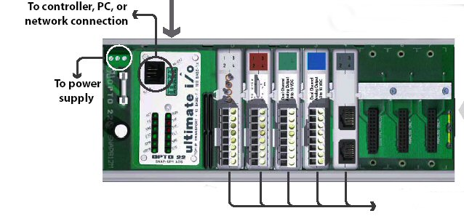
Figure 1 – SNAP module, with brain and IO modules.

The T3 Electronic Rack will house 3 or 4 Opto22 units that will handle the bulk of the IO requirement. An additional Opto22 unit is required for the new shutter JBox interface.

T3 Rack: 3 unit x 64 points = 192 points.
Shutter : 1 unit
Lab: 1 test units
Spare: 1 unit.

7.2 Estimate cost

Estimate includes 4 TCS3 unit, 1 lab units, 1 dome unit, and 1 provisional.

