5. Encoder Replacement

5.1 Top Level Encoder Requirements.

The encoder requirements for the new TCS are as follows:

Absolute position resolution: 6.0 arcsec, 3.0 desired [>6.0 arcsec is current TCS resolution]
Incremental position resolution: 0.01 arcsec [0.2 arcsec is current TCS resolution]
Maximum slew rate: 1200 arcsec/sec on sky
Maximum slew acceleration: 1200 arcsec/sec²
Environment: -10 to 50 deg C.
Humidity: 100% Relative Humidity.

The old TCS is currently unsupported and the implication of this is that we cannot modify any of the existing encoding hardware, until after the new encoders are commissioned. Unfortunately, the old encoders are installed at the best locations (easy access, stiffness, protected, etc.) on the telescope.

5.2 Current DEC and RA Absolute Encoding.

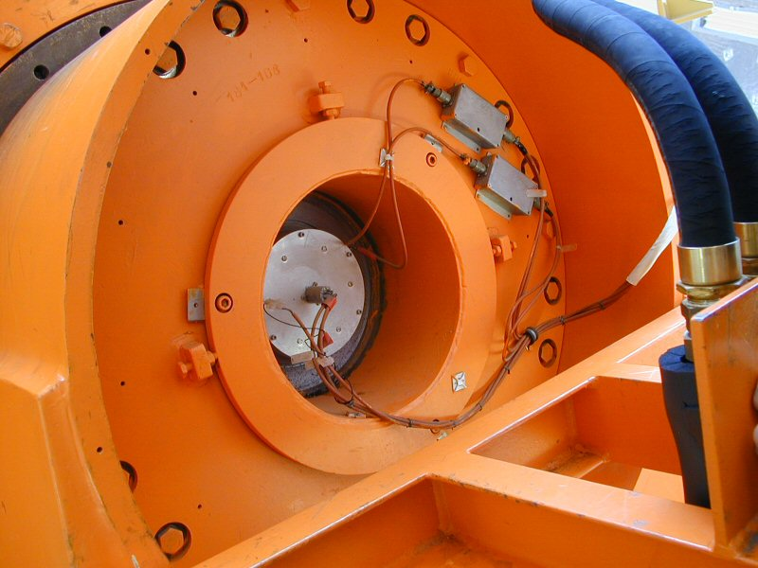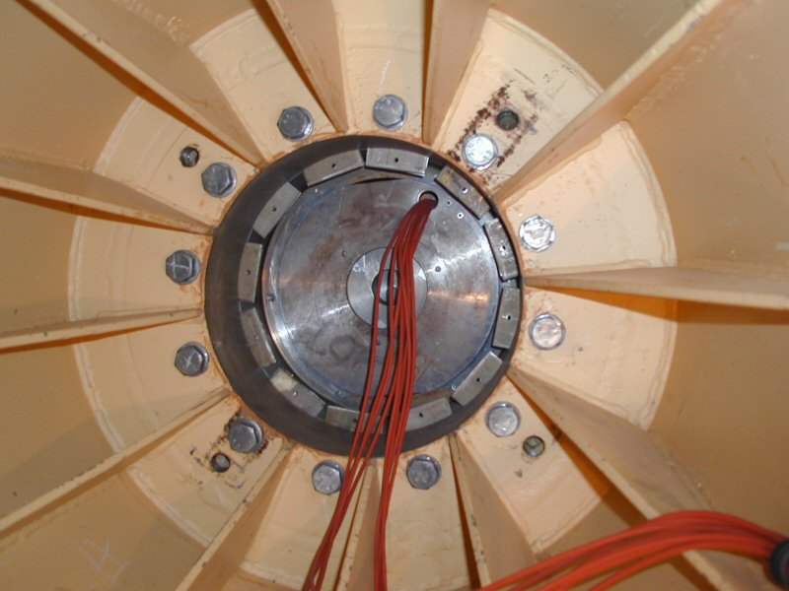
RA APE DEC APE

The current HA absolute position encoder (APE) is located in the North Pier. It is an inductosyn encoder with one half mounted on the yoke, and the other half mounted to the pier.

The DEC APE is located in the west arm of the yoke. It is also an induction type encoder (identical to the RA encoder) with one half mounted to the telescope central section, and the other half mounted on the yoke.

Both of the current APEs have a resolution of about 4 arc-seconds.
5.3 Current DEC and RA Incremental Encoding.

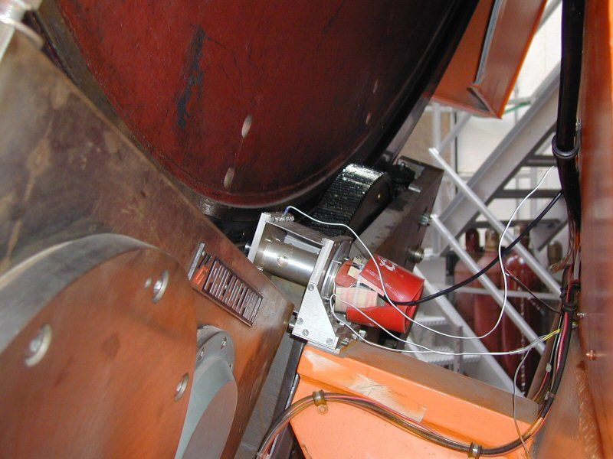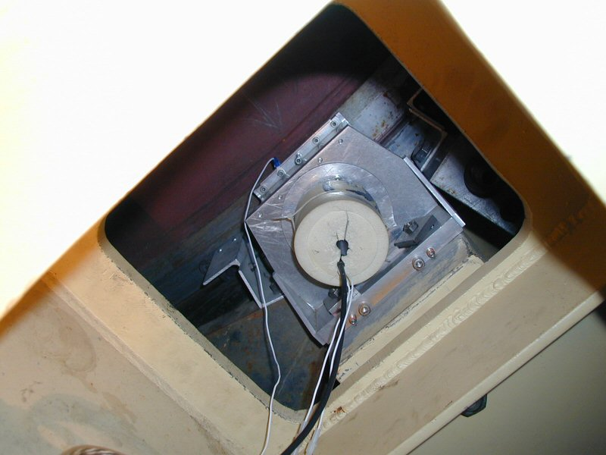
RA Inc. Encoder Dec Inc. Encoder

The current RA incremental encoder is located on the South Pier. It is an optical type encoder (manufacturer – Teledyne Gurley) driven through (approximately) a 180:1 gear ratio friction drive on the back of the bull gear.

The current DEC incremental encoder is located in the west arm of the yoke and access is from inside the yoke. It is also an optical type encoder (identical to the RA encoder) also driven through (approximately) a 180:1 gear ratio friction drive on the back of the bull gear.

Both of the current incremental encoders have a 3600 line count and associated electronics capable of 40x interpolation for a total of 144 000 pulses/ revolution. After accounting for the gear ratio, this works out to about (3600 x 40 x 180) / (360 x 60 x 60) = 20 pulses per arcsec or 0.05 arcsec resolution.

*** Currently, the exact gear ratio is determined through a calibration procedure and works out to be about 19.9041?!?

5.4 TCS3 Absolute Encoding

The T3 system will use the current APE, with upgraded electronics. The current APE was manufactured by Ruhle Companies, Inc (Farrand Controls Division). The mechanical components provide the desired resolutions, however the current interface electronics are custom to the MCC. New electronics will be purchased to interface the APE to the new T3 computer system. The switch over from TCS1 to TCS3 will be a matter of moving a cable at the north (HA) or west (Dec) yoke for the rotor/Stator output to either the TCS1 or TCS3 system.

The upgrade parts are listed in the table at the end of this section

These new electronic will increase the resolution from ~6 to less than 1 arc-second. The raw encoder data will require correlation to be preformed in software. They do not have a correlation module to match our Rotor/Stator. The correlation algorithm will be provided by Farrand Controls.

The IRTF doesn’t have a spare for the mechanical portion of the APE. A spare Encoder Rotor/Stator will be purchased from Farrand Controls.

The new APE electronics will be mounted in the north (HA) and west (Dec). Two 16 bit words per axis will be read and transmitted to a computer for correlation. The computers (1 per axis) that will read and transmit the data to the TCS3 computer will be an x86 embedded CPU with PC-104 interface running a Linux OS. A PC-104 DIO module is required to sample two 16-bits words. This module has not been selected.

It is desired to have both old and new APE electronics on-line. We will determine the feasibility of having both on-line, or implementing manual method of switch between the two systems at a future date.

The correlation logic was provided by Farrand Controls via faxes located at:
http://irtfweb.ifa.hawaii.edu/~tcs3/systems/tcs3/vendor_info/Farrand_Controls/0309_APE_correlation/

5.5 TCS3 Incremental Encoding

Similar to the case of the absolute encoders, the current incremental encoders are located in the optimal position. The fact that we cannot disturb these encoders until the new TCS3 has completed commissioning will make it necessary to install temporary incremental encoders. Once the new TCS3 system is commissioned, the encoders will be migrated to the current incremental encoder location.

These temporary absolute encoders will be installed on the bull gear through a friction drive and identical to the final encoder compliment. Since the encoder will be driven through the friction drive at an approximate gear ratio of 150:1, specialized hardware will have to be fabricated to provide alignment and tensioning. Every effort will be made to make the fabricated hardware for the temporary configuration identical to the hardware required for the final configuration.

Since the TCS3 computer may adjust the servo velocity based on positional error measured at 10 Hz, a resolution of 100 Hz (10 x 10 Hz) is highly desired.

A possible candidate for the incremental encoder is the Gurley Series 8235S rotary incremental encoder, along with series HR2A high resolution interpolator:

Line count = 11250 lines/rev
Interpolation = 80x
Gear ratio of 150:1

Yields 135 000 000 counts/rev of the bull gear
104.167 counts / arcsec on the sky
approx. 0.01 arcsec resolution

Also slew rate of 1200 arcsec/sec = 125 000 counts/sec (emerging from electronics)
(125 000 counts/sec) / (80) = 1562.5 Hz (emerging from encoder)

It would be desirable to find an encoder with higher resolution. This would allow us to work with a smaller gear ratio, mitigating many of the errors/problems that are associated with the friction drive. Several higher resolution encoders from Heidenhain will be investigated.

5.6 Current Dome Encoder

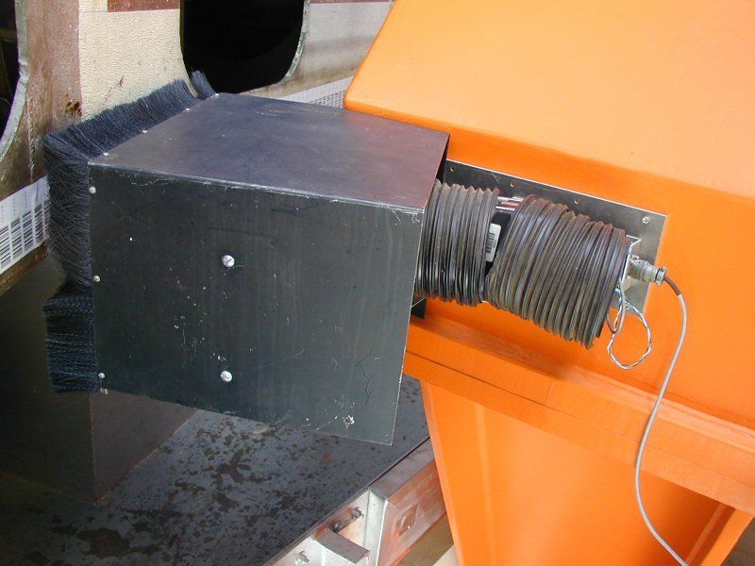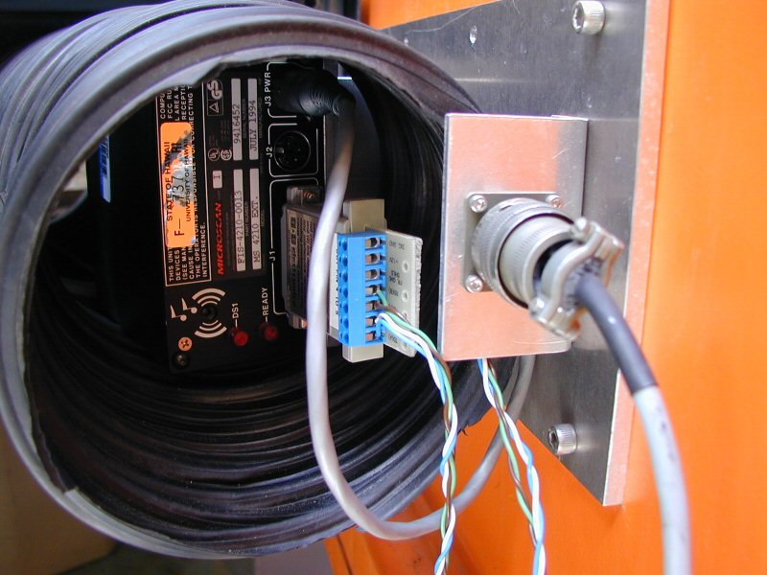
Dome Scanner (side view) Dome scanner (back)

The dome is encoded using a bar code label and a scanner. The scanner outputs is serial (RS-232?). The serial is converted into a parallel graycode using an embedded CPU board.

The barcode values range from 1 to 1800, giving the dome a resolution of 0.2 degrees.

5.7 Budget / Manpower

The IRTF will provide the mechanical, electrical, and software support via Bond, Keske, and Denault.

Initial cost estimates are as follows:

