TCS1 Encoder

This document describes the present TCS1 encoder hardware.

1. Absolute Position Encoders (APES)

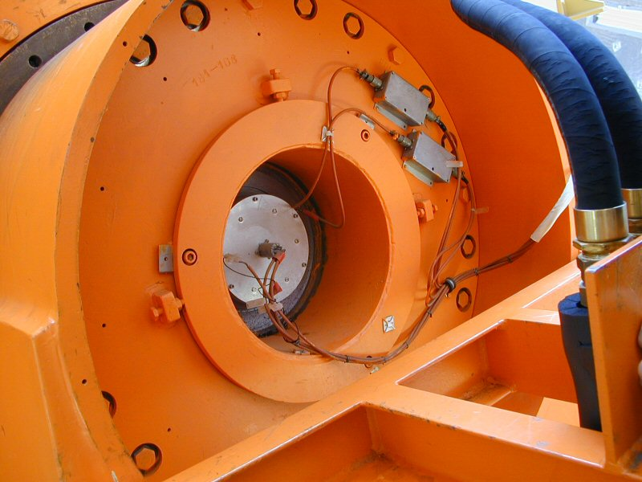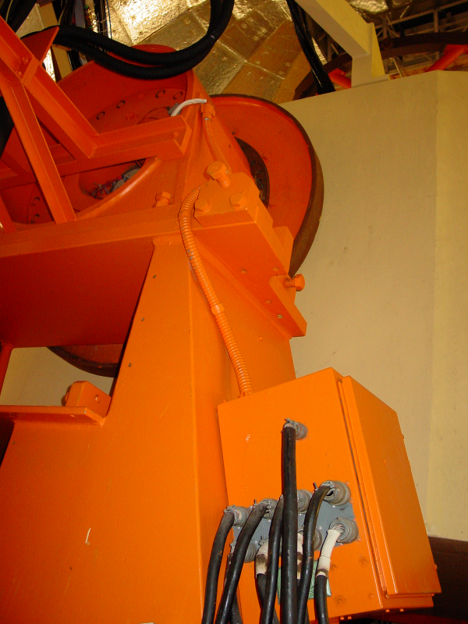
HA APE sensor & PreAmps HA JBOX

The Absolution Position Encoder (APE) sensors consist of a resolver and an inductosysn transductor, which provides coarse (0-360 degrees) and fine (~2-0.5 degrees ) resolutions. Electronics circuits combine the coarse and fine data into a 19-bit work. This parallel data is transmitted to the MCC using parallel-to-serial converts. The accuracy of the APE is about 6 arc seconds (resolution is much better).

The HA absolute position encoder (APE) is located at the North Pier. The sensor and amplifiers are located at the north axis, and JBOX with the A/D converter hardware is located on the side of the structure.
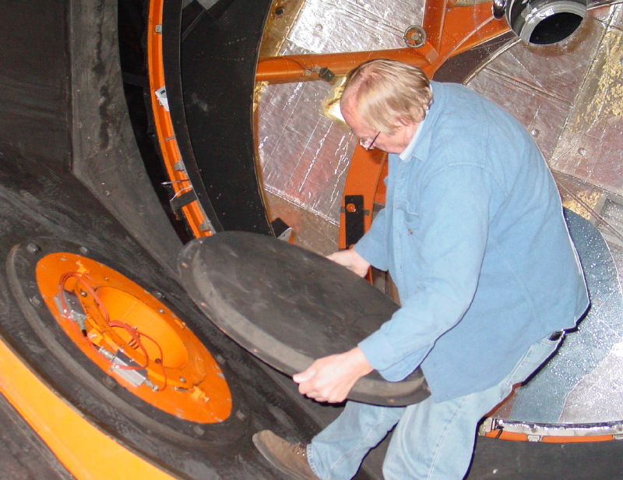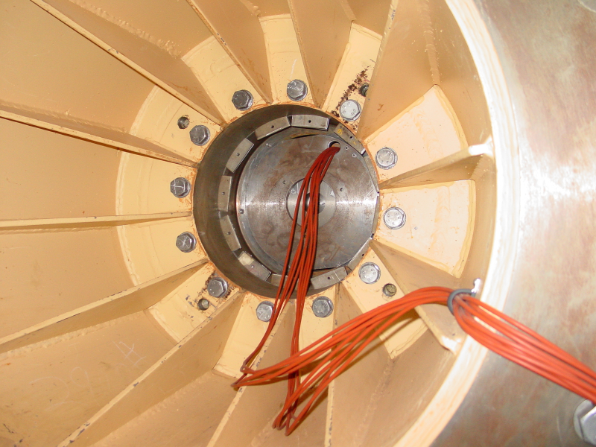
HA APE sensor & PreAmps in mirror cell West area of yoke (JBox out of view)

The DEC APE is located in the west arm of the yoke. This sensors and pre-amps are accessed by opening a cover in mirror cell at the west axis. The senor/preamp wiring exits via the west arm of the yoke where the JBox electronics.

2. Incremental Encoders.

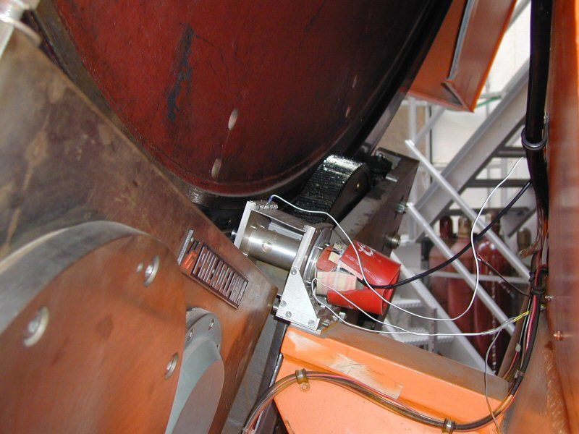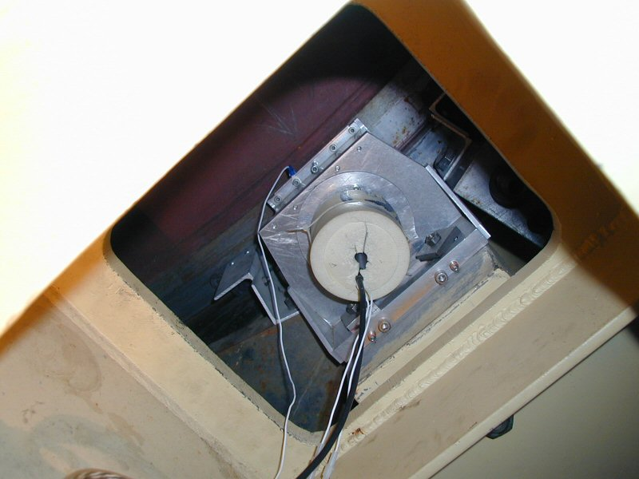
RA Inc. Encoder Dec Inc. Encoder

The current RA incremental encoder is located on the South Pier. It is an optical type encoder (manufacturer – Teledyne Gurley) driven through (approximately) a 180:1 gear ratio friction drive on the back of the bull gear.

The current DEC incremental encoder is located in the west arm of the yoke and access is from inside the yoke. It is also an optical type encoder (identical to the RA encoder) also driven through (approximately) a 180:1 gear ratio friction drive on the back of the bull gear.

Both of the current incremental encoders have a 3600 line count and associated electronics capable of 40x interpolation for a total of 144 000 pulses/ revolution. After accounting for the gear ratio, this works out to about (3600 x 40 x 180) / (360 x 60 x 60) = 20 pulses per arcsec or 0.05 arcsec resolution.

*** Currently, the exact gear ratio is determined through a calibration procedure and works out to be about 19.9041?!?

5.6 Dome Encoder
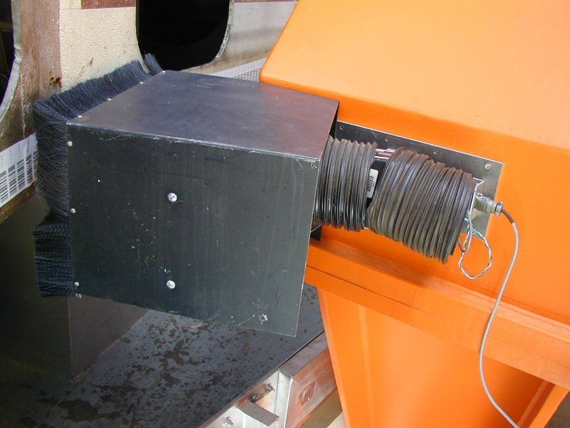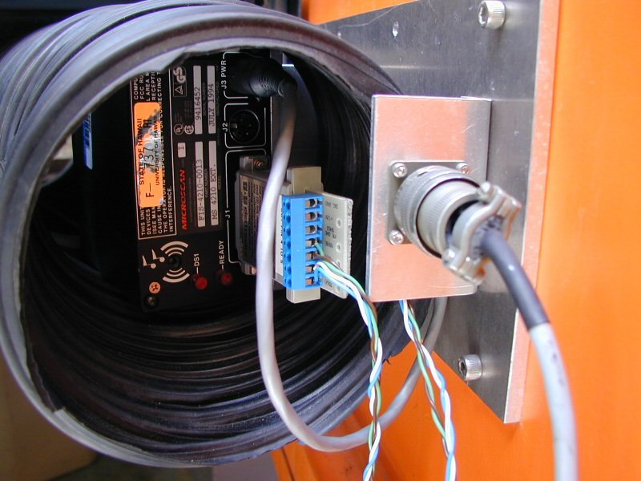
Dome Scanner (side view) Dome scanner (back)

The dome is encoded using a bar code label and a scanner. The scanner outputs is serial (RS-232?). The serial is converted into a parallel graycode using an embedded CPU board.

The barcode values range from 1 to 1800, giving the dome a resolution of 0.2 degrees.

