Note on installing the spare APE encoder electronics

In the event that the Absolute Position Encoder (APE) unit needs to be replaced with the spare unit, it will need to be calibrated for the particular axis that it will be installed on.

Also the Compact Flash boot disk for the system need to be changed (Also see section 3 – Software notes).
- Use the compact flash from the original APE CPU.
- Use the spare if the original failed.
- Re-configure the other Flash if #1 & #2 don’t work (to be done by software programmer)

After the unit is installed, the amplitude adjustment and the phase adjustment will be made for both the resolver and the Inductosyn boards by adjusting the potentiometers located on the PCBs within the housing. The 219060-16CJ board interfaces to the resolver which is the board in the left side of the housing, and the 219060-16FL interfaces to the Inductosyn which is the board in the right side of the housing, see photo.

To perform the adjustments, an oscilloscope will be needed to make the measurements.

Excitation Amplitude Adjustment
Monitor the 10k Hz (Inductosyn) or 2.4k Hz signal at the COS – HI wire connection point with the oscilloscope. The signal should change amplitude as the telescope is moved. Move the telescope to get a maximum signal and then adjust the DRIVE potentiometer to get a 2 volt rms signal. For the Inductosyn this is a very small movement, however for the resolver this may require that the telescope be moved many archours. For the DEC axis it will probably be very difficult to find the maximum amplitude point due to the mounted unit moving with the telescope. In this case move it as far as feasible possible and then adjust the potentiometer to a value slightly under 2 volts, i.e. 1.8 volts.

System Adjustment-Phase
Monitor the COS – HI wire connection point with the oscilloscope on one channel. Connect the other oscilloscope channel to the phase test point, TP-θ. Adjust the PHASE potentiometer until the two signals are in phase. Note for this adjustment the signals will either be in phase or 180° out of phase based on the position of the telescope. When the signals are out of phase either the telescope can be moved until the signals become close to being in phase or one of the signals on the oscilloscope can be inverted using the oscilloscope invert function and then the adjustment can be made.

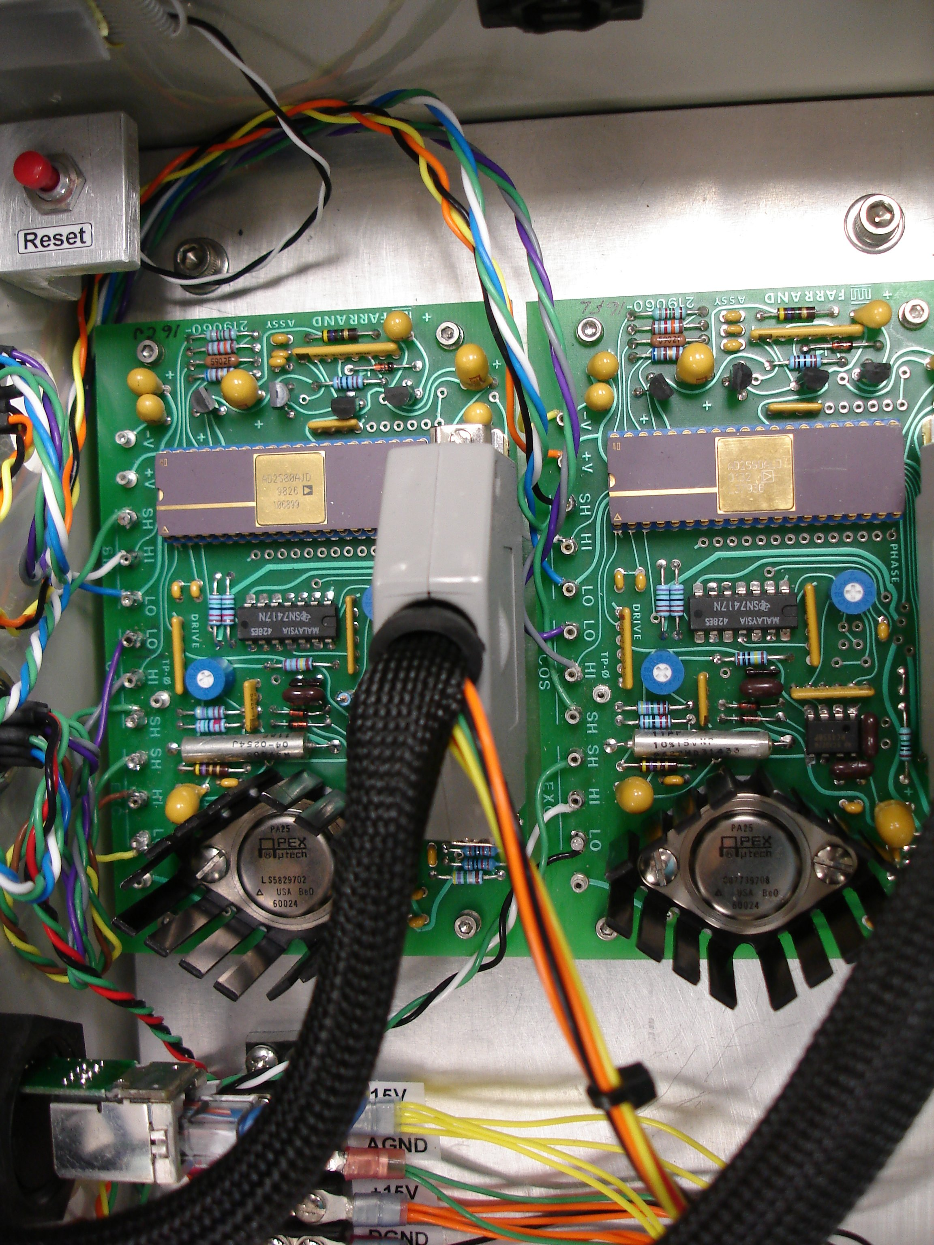
Figure 1

Software Notes

- Before swapping in the spare hardware, the compact flash card from the original unit should be used in the spare. Simply swap the card on the embedded PC.

- The spare electronic unit also comes with a SPARE HA and Dec flash disk incase the originals failed.

- If the card on the spare needs to be configures, then you must prepare the spare compact flash with the configuration and application for either the HA or Dec. The spareCF has been configured in a similar fashion, but you should check the following:

Hostname and IP settting files (also review the files in /home/tcs3/public_html/systems/tcs3/computers/embeddedx86/, this contains info on setup the CFcard as the boot disk).

  - /etc/sysconfig/ifcfg-eth0
  - /etc/sysconfig/network_cfg
  - /etc/hosts

Also note the filesystems are backed up on the /irtf.backup directories.

- APE applications

The directory, /home/tcs3/src/tcs3/embeddedx86/ape/, contains the source code and instructions on installing the APE application on the CF boot disk. Note the HA and Dec uses the same binary, but the /etc/init.d startup scripts provide application options for either the HA or DEC axis.

BE SURE YOU USED THE CORRECT /etc/init.d script for starting up the APE sotware. The HA and DEC APE have difference coefficients values to convert encoder counts radians. These coefficients and the IP/hostname are on only differences on the flash disk.

