UNIVERSITY OF HAWAII
INSTITUTE FOR ASTRONOMY
2680 Woodlawn Dr.
Honolulu, HI
96822
NASA Infrared Telescope Facility
TCS Axis Motor Tachometer Replacement

Eric Warmbier
July 29, 2026
Version -

Table of Contents
1 Executive Summary 3
2 Introduction 3
2.1 Issues 3
2.2 Options 4
3 Option 1: Maintain Current Tachometers 4
3.1 New Material Costs 4
3.2 New Labor Costs 4
3.3 Maintenance 4
3.4 Performance 4
4 Option 2: Off the Shelf Tachometers 4
4.1 New Material Costs 4
4.2 New Labor Costs 4
4.3 Maintenance 4
4.4 Performance 5
5 Option 3: Incremental Encoders 5
5.1 New Material Costs 5
5.2 New Labor Costs 5
5.3 Maintenance 5
5.4 Performance 5
6 Appendix 6
Figures and Tables
Figure 1 GE standard tachometers 6
Figure 2 Danaher frequency to voltage converter 7
Figure 3 Gurley R158 optical encoder 8

Table 1 Summary of Options 4

Executive Summary
The 4 original axis motor tachometers are currently still in use at the IRTF. Due to their mechanical nature, they require maintenance to their brushes and due to their age, they may require more extensive repair in the near future. This report outlines and compares 3 of the most likely choices regarding the replacement (or repair) of the tachometers. Below is a color coded table with 5 ratings (very low, low, medium, high, and very high) for each category.
Option | Material Cost | Labor Cost | Maintenance | Performance Issues | Overall Positives | Overall Negatives
Maintain Current Tachometer | Very Low to Very High  Stock=Very Low (free)  New = Very High  ($10,00 per armature,  $2,000 per brush) | Very Low  (none) | Medium  (brushes and armatures) | Very Low  (no issues - in use) | Inexpensive, assuming no major issues | Continuous maintenance, Part Availability
Off-the-shelf generator Tachometer | Medium  ($2,000+ per generator tach)  + mounting material | Medium | Medium  (brushes) | Very High  (Sensitivity over 6 times lower, not rated at low RPM (<100)) | Off-the-shelf units by major manufacturer (GE) | Performance very questionable
Optical Encoder w/ Conversion | Medium  $1,000 or less per encoder, $575 per converter  + mounting material | Medium to High | Very Low  (almost none) | Low  (high accuracy, low ripple) | Near zero maintenance, off- the-shelf, may have improved ripple | May have to build own conversion board
Table 1 Summary of Options

Introduction
The IRTF telescope HA and Dec axis each have two opposing motors that rotate their axes. Each motor has its own tachometer directly coupled to its shaft. The tachometers are DC tachometer generators which provide a voltage directly proportional to shaft speed. They were designed and built in the 1970s and are specially designed to provide a high output voltage per rpm. The age, part availability, and maintenance are issue associated with the current tachometers. This report presents the tradeoffs with maintaining the current tachometers vs. replacement options.

Note: A supporting Mathcad file (“Tachometer_Replacement.xmcd”) contains calculations to determine what is required for the new options. Some numbers used in the report are also derived the Mathcad document.

Issues
The tachometers are older and out of production, so obtaining more parts, if required, is an issue. The issue other is maintenance. The tachometers are essentially DC generators which have brushes that make physical contact with the armature. The physical contact creates wear as the shafts rotate. The brushes can also become dirty and require cleaning. This maintenance has been part of the routine maintenance at the IRTF for years. However, with advances in technology, another solution is possible that may be nearly maintenance free.

Options
There are multiple, practical options available that range from simply maintaining the current tachometers, purchasing off-the-shelf tachometers, or using optical incremental encoders. These are the 3 options considered in this report. There are other options, however, many cannot meet the requirements due to the extremely low rpm of the motors – tracking is 0.1 rpm and slewing is 13 rpm. Keep this fact in mind if considering another option that is not explored in this report.

Option 1: Maintain Current Tachometers

New Material Costs
There are no new material costs. Two armatures and 4 brushes are in IRTF stock (as of 7/9/08). However, since the tachometers are out of date, new tachometer parts are custom built by the original manufacturer. The last order placed (Z783053, 7/14/2006) was for 1 armature at $9,891.20 and 5 brushes at $1,891.00 each.

New Labor Costs
There are no new labor costs. The tachometers are installed.

Maintenance
Maintenance consists of cleaning the brushes on a regular basis and replacing the armatures and brushes as required. According to George, it appears as if 1 or 2 of the armatures may need to be replaced in the near future. Determining when or if this needs to happen is another discussion outside of this report. However, using two armatures would reduce the stock to zero.

Performance
Performance is not in question. These tachometers have worked for decades.

Option 2: Off the Shelf Tachometers
Purchasing new off-the-shelf tachometers is one option that ensures availability of parts or new units and should offer the lowest price. Looking at custom or specialized tachometers would likely not make financial sense since the cost would be much higher and the maintenance remains.

New Material Costs
New, standard, GE generators tachometers can be purchased for around $2,000 (model D137). New mounting brackets would also have to be made.

New Labor Costs
Labor would consist of fabricating the new brackets and installing the new tachometers. Wiring does not change. A few resistors and capacitors would have to be changed on the Safety Board, but that is very minor.

Maintenance
Maintenance will consist of cleaning or replacing the brushes on a regular basis. This will be similar to the current tachometers since the GE tachometers would also be DC generators with brushes.

Performance
This is one area which is very questionable. The tachometers on the IRTF have a very high voltage output per rpm that is much higher than most industry standard tachometer generators. The telescope requires this to achieve usable signal to noise ratios because of the low rpm at tracking (0.1 rpm) and relatively low rpm at slew (13 rpm). The GE tachometer has a rating of 200V/1000 rpm compared the approximately 1300V/1000rpm of the current tachometer. This is over a factor of 6 in terms of sensitivity.

Option 3: Incremental Encoders
Incremental encoders have offered increasingly higher counts/revolution at relatively low prices over the years. Given enough counts per revolution, accurate rotational speeds can be calculated, even at very low rpm using some type of frequency to voltage converter.

New Material Costs
As an example, Gurley offers a 1,000,000 count per revolution optical encoder (model R158) for about $1,000. There are other vendors to choose from, however, this is one example. There are off-the-shelf converter modules available to convert the pulses to an analog voltage. One example is the FV2 by Danaher for $575.00.

New Labor Costs
This category is somewhat variable for this option. Some mounting brackets will have to be made and some wiring modifications will have to be done. A few resistors and capacitors would have to be changed on the Safety Board, but that is very minor. If a suitable frequency to voltage converter cannot be found, then a custom board will have to be built. The design is not terribly complex, but it still requires making a design, schematic, PCB, and building the board.

Maintenance
This is one area where the encoder outperforms the other options and was one of the main reasons behind this report. The maintenance is virtually zero for the encoder. It is an optical encoder with the only mechanical parts being the bearings. Only when the bearings wear out or the electrical components fail will the encoder ever need to be serviced.

Performance
The absolute minimum encoder counts/revolution will need to be about 91,000 counts/revolution. This is due to the 0.1 rpm tracking rate and 152 Hz filter for the tachometer input that is currently used for filtering the generator tachometers. Therefore, 1,000,000 counts/revolution is more than sufficient. A suitable converter would have to be purchased or a board would have to be built that converts quickly enough to avoid lag. The digital version may produce a lower voltage ripple than the tachometer generator and may also produce a higher usable bandwidth, although the higher bandwidth may be unnecessary. It is hard to verify these possible benefits without some further analysis, testing, and a real unit. One issue may be that the encoder is not guaranteed to work below 0C. If temperature is found to be an issue, simple heater tape and insulation is a possible remedy.

Appendix
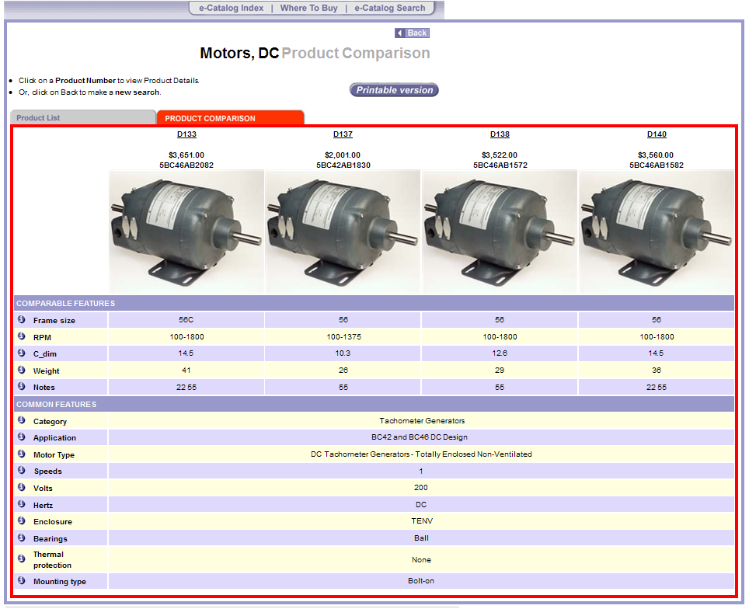

Figure 1 GE standard tachometers

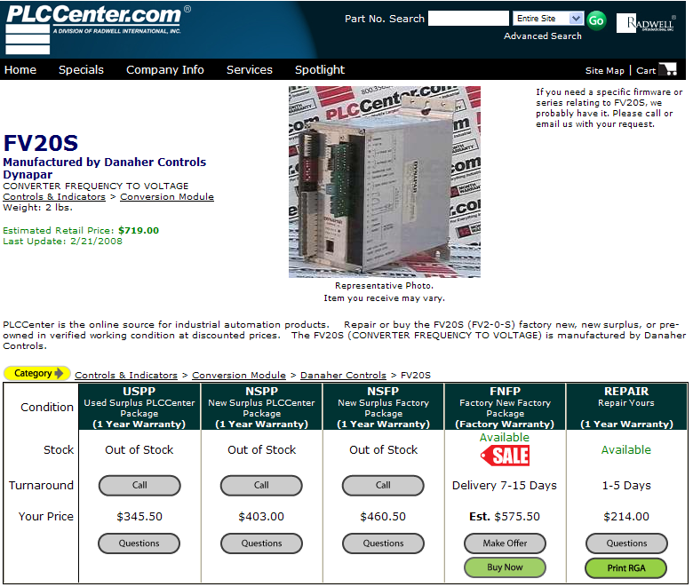

Figure 2 Danaher frequency to voltage converter

Figure 3 Gurley R158 optical encoder

