T3Remote

The Remote GUI for TCS3

T3Remote 1
1. Introduction 3
2. T3Remote 3
3. Display Status Area 4
4. Offset Tab 6
5. Next Tab 7
6. Focus Tab 8
7. (User) Spiral Tab 9
8. PtMap Tab 10
9. CMD Tab 10

1. Introduction

T3Remote is a mini-gui for the tcs3. It is intended to be used by observers and the Telescope Operator. It is installed and runs on the IRTF workstation. Multiple copies can be running by various number of users.

To start t3remote, type “t3remote” on you console terminal. The GUI should appear.

Usage: t3remote [–d] [–h hostname]
-d Turn on the debug flag.
-h hostname Sets the tcs3 computer’s hostname
-m Use Medium size font for status. Hides the Main Tabs window.
-l Use Large size font for status. Hides the Main Tabs window.
-t Tabs only. The status display is hidden.

2. T3Remote

The GUI has 2 main sections:

Status Display
Main Tab provides various types of control widgets to the TCS3.

Here is a picture of the GUI:

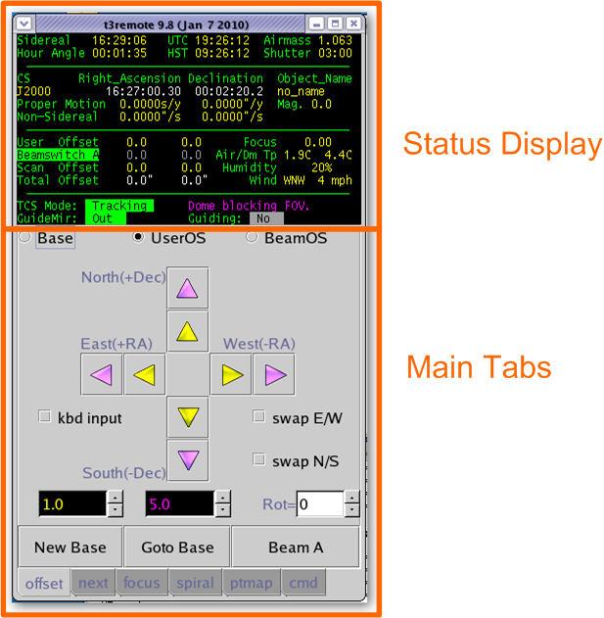

You can use larger font for the status using the –m or –l command line option. Using –m or –l will only display the status. You can run another copy using the –t, to display the Main Tab (without status) . There is an example, 2 t3remote running: 1) large fonts, 2) with tabs only.

> t3remote –l
> t3remote –t

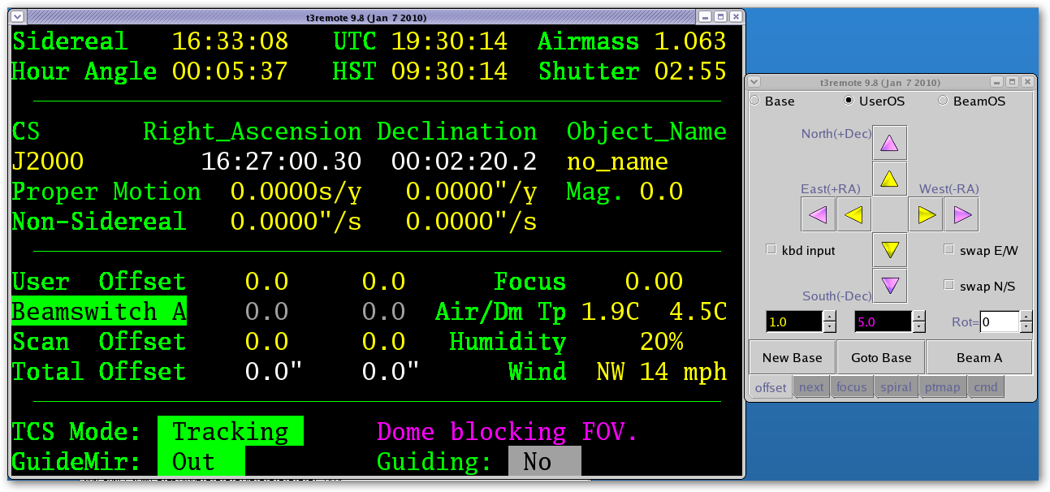

3. Display Status Area

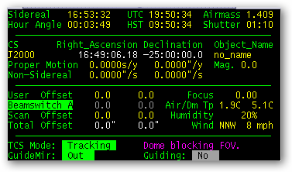

The Display Status Area provides status from the TCS3. Data provided includes:

Sidereal – The Local Sidereal Time.
Hour Angle – The observed Hour Angle position.
UTC – Coordinated Universal Time
HST – The local time, Hawaii Standard Time.
Airmass – Air mass
Shutter – Time in HH:MM until the shutter will block the field of view.

CS – The Celestially Coordination frame of reference for the RA and Dec positions.
J2000 = The FK5 reference frame using the Equinox of J2000.0
B1950 = The FK4 reference frame using the Equinox of B1950.0
App = Topocentric Apparent.
Other the ‘FK4’ or ‘FK5’ is display with its Equinox values.
Right Ascension – Target Right Ascension (target is base position + offsets ).
Declination – Target Declination

Object Name – The object name field from the ptable (TCS3 position table).
Proper motion – display proper motion ra (s/yr) and dec (“/yr).
Non-Sidereal – The non-sidereal rate in “/s.
Mag. – The magnitude value from the position table.

User – User offset magnitude display; color coded yellow when applied, gray when disabled.
Beamswitch A or B – Indicates the beam position, and offset magnitude.
Scan – offset applied from the scan offset.
Total – display the total offset added to the base, resulting in the target RA Dec position.

Focus – display the actual focus position (actual is the position sensor value).
Temp. – The temperature in degree C.

TCS Mode – provide to operating mode of the TCS. They are:
Stop – telescope is parked: servo is off; brakes are on.
MP – Move Postion mode (non-observing positional moves).
MV – Move Velocity mode (non-observing velocity moves).
Track – Track the sky position specifed by the tracking table.
slew – Slewing to a tracking position.

To the right of TCS Mode, relevant status is displayed for current TCS Mode.
During tracking, you may see:
Dome is ready
Dome moving..sec (where sec is estimated seconds in current move)
Dome blocking FOV (Field of view)
During Slew, the estimated time to the end of the slew is displayed.

GuideMir: Display the location of the off/on axis guider mirror.
Out – means the mirror in out of the optical path (green text).
In – means the mirror is blocking the optical path to the instrument (Red)
Unkn – means the position is not known by the TCS.

Guiding – Indicates if guiding is active (YES) or not (NO). Guiding YES, occurs when peaking up the pointing map using the guider or manually. YES is display when the TCS receives 5 guiding updates within the last 60 seconds.

4. Offset Tab

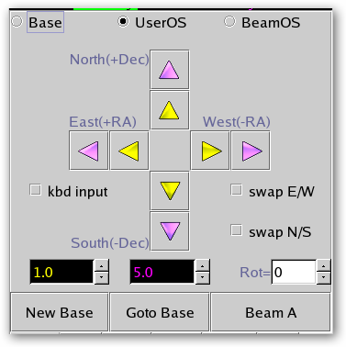

The Offset Tab allows the users to increment the base coordinates and/or offsets.
First select the coordinate to change from the top radio buttons:
Base – Base RA and Dec position
UserOS – User offsets.
BeamOS – Beam offsets.
Use the spinbuttons (yellow and magenta input fields) near the bottom to set the magnitude of the offset. Units are in arc seconds, and the color indicate the which buttons they are for.
The Rot= input specifies a rotation for the offset request. The units are in degrees.
Click on the Arrow Buttons to move or change the OS values.
The swap E/W or swap N/S allows you to change the direction of the buttons.
The kbd input, when checked, allow the keyboard arrow key to function like the Yellow buttons.

The NewBase button will make the current position the new base (zeroing any active offsets).
The Goto Base button will zero the user offset (using “user.set 0 0 “).
The Beam Switch button’s label will read Beam A or Beam B to indicated the current beam position. Press this button to toggle the beam position.

5. Next Tab

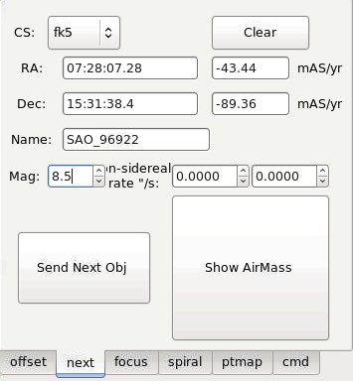

The Next Tab also you to send the next or slew destination to the TCS.
After entering the sky coordinates, and press the Sent Next Obj button to sent you slew request to the TCS.

CS – The Celestial Coordinate System Reference Frame:
Fk4 – The RA and DEC is in the FK4 Reference Frame. Its standard Equinox of B1950.0 is assumed.
Fk5 – The RA and DEC is in the FK5 Reference Frame. Its standard Equinox of J2000 is assumed.
Apparent – The RA and DEC is in geocentric apparent reference frame.
Note: For ICRS coordinates, used CS of fk5.
RA – Right Ascension in hours. Note the following formats are equivalent:
18:02:23.05
18 02 23.05
18.03973611
Dec – Declination in +/- degrees. Note the following formats are equivalent:
19:48:58.0
19 48 58.0
19.816111
PM – proper motion. RA proper motion in mAS/yr. Epoch for proper motion correct is implied by the CS value.
Name – a name for the object.
Mag – a visual magnitude (optional)
Non-sidereal rate “/s – RA and Dec non-sidereal rates in arcseconds/second.

Press the Show AirMass button to display the HA, and Airmass for the entered RA, Dec position.
6. Focus Tab
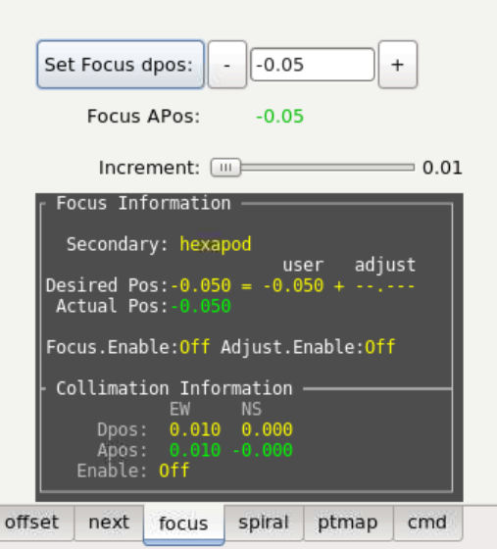

The Focus Tab allows the observer to change the telescope focus.

To set the focus desired position, enter a new value in the text widget, then press the Set Focus dpos: button. The new position should be updated in the Focus Information area.

You can decrement or increment the desired focus position by pressing the “-“ and “+” buttons. The incremented amount is control by the slider below labeled “Increment”.

Focus APos The apos is the actual position returned by the focus position sensor. APos is GREEN when the focus in ‘in position’ or match the desired position. Red otherwise.

Focus Information:
The feedback area proves details on the focus and collimation values.
Secondary: The IRTF has 2 secondaries: hexapod, and chopper. This shows the current secondary being used.
Status or feedback information is presented in the black display area.
The Desired Pos is where the focus mechanism is commanded to. The position is determined by the User Dpos (entered by the user) plus the Adjustment value. The adjustment value is a temperature and telescope position adjustment applied in real-time. This adjustment value is used when Adjust.Enable is ON. Information on how temperature and position affect focus is in the TCS3 Operators Guide.

Collimation information is also displayed here. The desired position (Dpos) and Actual position (Apos) is display. Apos is GREEN when collimation in ‘in position’, otherwise Red is used. The Collimation Enable is shows if the collimation software loop is active (ON) or not (OFF).

7. (User) Spiral Tab

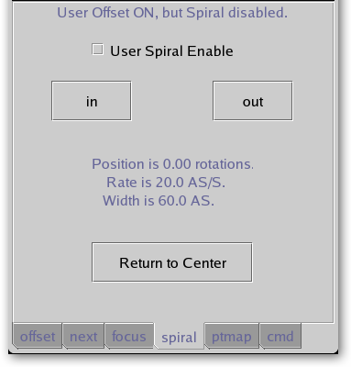

The Spiral Tab allows the observer to spiral the telescope. The spiral RA and Dec offset are place the the User Offset. To sprial, check the User Spiral Enable. Note that User Spiral disables user’s offset.

Press the out button to spiral outwards, use the in button to spiral inwards.

The Position tells you your location on the spiral in terms of rotations. The RA and Dec offset values can be seen on the Users (on the status display).

The Rate and Width is display for your reference. The TO can adjust these values using the User.Spiral.Rate and User.Spiral.Wid commands.

The Return to Center button set the rotation to 0 (center of the spiral).

8. PtMap Tab
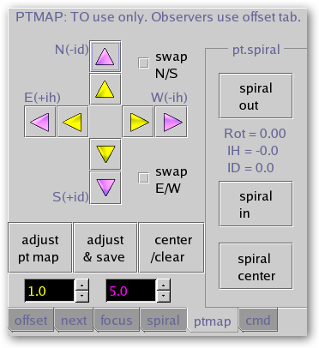

The PtMap Tab is the Point Map Table. These controls should be used by the Telescope Operator only (not the Observer).

The arrow keys allow you to peak up the IH and ID corrections values. Use the yellow and magenta spin buttons to set the displacement, units are in arcseconds. The swap N/S or E/W check buttons allow you to reverse the HA or Dec directions.

Adjust pt map – issues pt.madj command to add corrections values to MAdj (Map Adjustment) registers.
Adjust & Save – issue pt.save: does a pt.madj AND saves MAdj values in the ic/pt.save.txt files for recall at restart.
Center/Clear – Issues Pt.clear to zeros the MAdj, Spiral, and Rates registers.

The pointing map spiral can be controlled using the widget in the pt.spiral frame.
Spiral out – spirals outwards.
Spiral in - spirals inwards.
Spiral center – issues Sp.center sets the rotation to 0.
The spiral Rotation, IH, ID vales are displayed inside the pr.spiral frame.

9. CMD Tab

The CMD Tab allows t3remote command to be typed in using the keyboard. These are not TCS3 command (command defined the tcs3 command dictionary). In normal operations, neither the TO or Observer should use this tab.

